**CHAPTER -01**

**SYNOPSIS**

**1.1 ABSTRACT**

E-Band Health Monitoring System which sends the Heart-rate Datasets of an Individual consistently/hour to the cloud for performing "Sickness Predictive Analytics". The System which keeps running on the Backend/cloud, executes different Data Mining Techniques like Classification, produces the Analysis providing details regarding heart-rate varieties consistently. The System likewise serve the clients with constant notices of their heart condition and aides them with appropriate medicinal services. This sort of data can be of an incentive to the medicinal group. Heart Rate Variability Analysis predicts future heart ailments in people, alarming them ahead of time. On the off chance that when the patient gets lethal the beat sensor will detect the patient's heartbeat rate instantly and it will alarm his relatives by sending the patient's location through GPS co-ordinates by sending alert messages through ThingTweet. The ceaselessly checked information is put away in the cloud for encourage examination and forecast. The framework additionally gives an android application which helps in daily report generation of the patient’s health status.

**1.2 Keywords:** Pulse, Heart Beat, GPS, GSM, Wearable, Internet of Things (IOT), Heart rate variability (HRV)

**1.3 PROBLEM STATEMENT**

A person can be diseased if the heart rate increases or decreases linearly over a period of time. This cannot be regularly monitored by people because of their busy schedules. In this case, the E-BAND Health Monitoring System monitors the patient’s health status and it generates daily reports based on patient’s health.On the off chance that when the patient gets lethal the beat sensor will detect the patient's heartbeat rate instantly and it will alarm his relatives by sending the patient's location through GPS co-ordinates by sending alert messages on the cell phone. Patient can view daily health status on the webapp.

**1.4 GOALS AND OBJECTIVES**

**Objectives:**

* Internet of Things (IoT) is the developing innovation, which contains gigantic measure of savvy protest and brilliant gadgets associated with the web for speaking with each other.
* This project intends to realize a device that can read the human pulse rate from a fingertip.
* The pulse rate in the unit of beats per minute (BPM) will be displayed on ThingSpeak cloud as well as webapp.
* According to the National Institute of Health, the average resting heart rate for children 10 years and older, and adults (including seniors) is 60 - 100 beats per minute.
* Well-trained athletes is 40 - 60 beats per minute. So this device will indicate a too high pulse as well. A real-time plot of pulse signal versus time will be displayed on a laptop screen.
* In this undertaking to examine and process the patient wellbeing we are utilizing Node MCU and Pulse Sensor which is the core of this undertaking
* These brilliant gadgets are utilized to gather pulse state of the patient.
* The last outcomes are shown on the webapp, on web server and furthermore the outcomes are sent to the client through SMS through ThingTweet (Cloud Platform SMS Service).
* These information results can be put away in information base focus which can be summoned from remote area whenever in a crisis instance of patient without postponing the time.
* This undertaking may assume crucial part in sparing the patient life at crisis time since "Time is life".

**Goals:**

This research is aimed at investigating and development of optimized solution to fulfil these objectives for pervasively secure remote patient monitoring.

* **Patient Safety:** Patients should not be harmed by health care services that are intended to help them. The IOM report, ***To Err Is Human*** found that between 46,000 and 98,000 Americans were dying in hospitals each year due to medical errors. Subsequent research has found medical errors common across all health care settings. The problem is not due to the lack of dedication to quality care by health professionals, but due to the lack of systems that prevent errors from occurring and/or prevent medical errors from reaching the patient.
* **Effectiveness:** Effective care is based on scientific evidence that treatment will increase the likelihood of desired health outcomes. Evidence comes from laboratory experiments, clinical research (usually randomized controlled trials), epidemiological studies, and outcomes research. The availability and strength of evidence varies by disorder and treatment.
* **Timeliness:** Seeking and receiving health care is frequently associated with delays in obtaining an appointment and waiting in emergency rooms and doctors’ offices. Failure to provide timely care can deny people critically needed services or allow health conditions to progress and outcomes to worsen. Health care needs to be organized to meet the needs of patients in a timely manner.
* **Patient Centered:** Patient-centered care recognizes that listening to the patient’s needs, values, and preferences is essential to providing high-quality care. Health care services should be personalized for each patient, care should be coordinated, family and friends on whom the patient relies should be involved, and care should provide physical comfort and emotional support.
* **Efficiency:** The U.S. health care system is the most expensive in the world, yet there is consistent evidence that the United States does not produce the best health outcomesor the highest levels of satisfaction.The goal is to continually identify waste and inefficiency in the provision of health care services and eliminate them.
* **Equity:** The health care system should benefit all people. The evidence is strong and convincing that the current system fails to accomplish this goal. The IOM report, ***Unequal Treatment***,documented pervasive differences in the care received by racial and ethnic minorities. The findings were that racial and ethnic minorities are receiving poorer quality of care than the majority population, even after accounting for differences in access to health services.

**1.5 RELEVANT MATHEMATICS ASSOCIATED WITH THE PROJECT**

To predict a heart rate for a specific point in time we use mathematics to model heart rates and predict what it might be in 5, 15, 30 and 60 seconds. The model used is known as linear regression and in the field of statistics is expressed as:  
 **y**=**Χβ**+**ε** where (1)

**Χ** is the regressors, or in plain english it will be 5, 15, 30 and 60 seconds time points where we want to predict your heart rate.

**β** is the regression coefficients. Statistical estimation and inference determines these values and are interpreted as the partial derivatives of the depend variable with respect to the independent variables. In the case of this app a sample of previous heart rate measures. There are more than one methodology to calculate these estimates, the one we use a technique as ordinary least squares (OLS) that minimise the sum of squared residuals to estimate the parameter **β** such that:

**β**=(**Χ**T**X**)-1**Χ**T**y** holds (2)

**ε** is the error term or sometimes known as noise. This variables captures things that might influence the model are not intended to take into account. Like all models there are assumptions and without going into the nitty gritty of the maths, they are:

1. We assume weak erogeneity. It simply means our heart rate is not random; we don’t expect a heart rate of 140 bpm and then suddenly 60 bpm within 1 second.
2. Linearity. We assume that the average of heart rate measurement is a linear combination of the regressions coefficients and time.
3. Homoscedasticity. It means that within out time frame of the model (i.e. 60 seconds), all the response variables has the same variance (i.e. volatility) in regard of the predators variables (in the App time is the predictor).
4. Independence of errors. The model assumes that the errors in the response variables are uncorrelated. (i.e.unrelated). For example, we say that the fact that you pick up a water bottle cannot be predicted and is random.
5. Lack of multicollinearity. Since the prediction time is under 60 seconds this does not apply, unless your training repetition is under 60 seconds.

BPM = 60∑ ([𝑖]−𝑇[𝑖 −1])/(𝑚−1) 𝑚𝑖=1

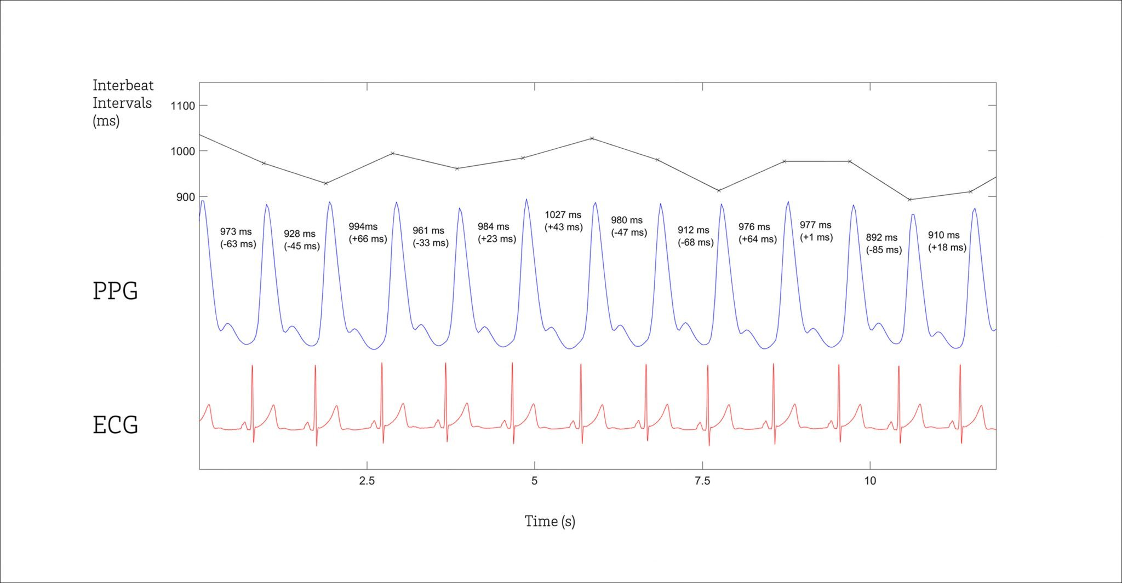

**Figure 1.1: Interbeat Intervals (PPG & ECG)**

**1.6 NAMES OF CONFERENCES / JOURNALS WHERE PAPERS CAN BE PUBLISHED**

Elsevier

Elsevier is an information and analytics company and one of the world's major providers of scientific, technical, and medical information. It was established in 1880 as a publishing company.

ICJ (The Indian Concrete Journal)

**1.7 REVIEW OF CONFERENCE/JOURNAL PAPERS SUPPORTING PROJECT IDEA**

**1.8 PLAN OF PROJECT EXECUTION**

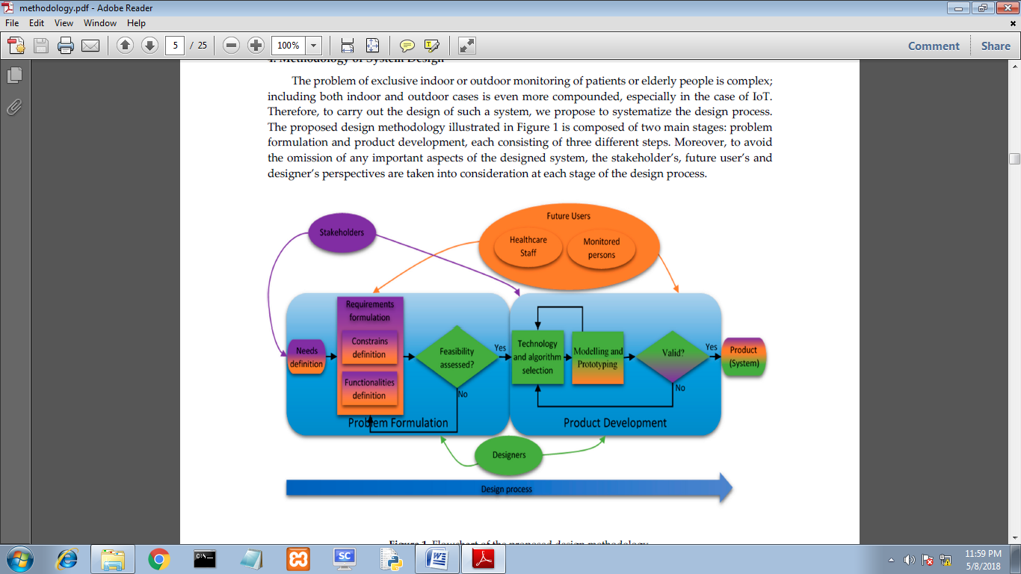

**Figure 1.2: Plan of Project Execution**

**Problem Formulation**

The problem formulation stage consists of three steps: need definition, requirement formulation and feasibility assessment. Since an essential aspect of the proposed DM is the involvement of all project contributors, i.e., stakeholders, future users and designers, each of them may have a contribution to the problem formulation. However, their goals and expectations of the future system can differ. For example, the user can focus on convenience, safety and confidentiality; the healthcare staff may aim at the system’s reliability, ease of operation and maintenance, along with the utility of the obtained information. The stakeholders additionally consider financial and marketing aspects of the product, and then, the designers focus on the design tools and their knowledge and experience.

**Needs Definition**

This step begins the design process when the stakeholders introduce to the designers the concept and define the general problem. In the proposed DM, this stage should be performed together with the future users in order to include their desires. With such an approach, both stakeholders and future users can express their needs and expectations of the outcome of the working system. In this step, participants should not focus on detailed requirements, but rather general goals of the system, so that the designers would be able to preliminarily assess whether the problem is solvable with their resources.

**Requirements Formulation**

The requirements formulation is the essential step of the proposed DM. At this stage, the

stakeholders and future users firstly formulate the desired system’s functionalities such as fall

detection or localization of monitored person. Furthermore, the constraints associated with the developed system like costs, size and required lifetime are introduced. In a case of

multi-environmental usage, the functionalities and constraints in each of the considered

environments have to be defined. These functionalities and constraints constitute the requirementsfor the designers; moreover, this is how the stakeholders and future users can indirectly affect thestructure of the developed healthcare system.

**Feasibility Assessment**

The designers have to assess the feasibility of the general needs and specified requirements formulated by the stakeholders and future users. Moreover, they have to consider whether the

existing possible solutions are able to solve the stated problems and assess whether the needs and requirements are realizable at all. The designers have to take into account also the constraints resulting from the desired working environments. If the designers encounter a problem in accomplishing the requirements, the stakeholders and future users would be asked to modify the requirements in a way that can satisfy them. After assessing that, all requirements can be met, andthen, the product development stage can begin.

**Product Development**

Usually, due to the challenging trade-offs and diversity of the desired functionalities and

constraints, the selection of suitable technologies and algorithms has to be carried out carefully in the following three steps: technologies and algorithms’ selection; modeling and prototyping; and then solution validation. Furthermore, at this design phase, the stakeholders and future users are involved; however, it is the designers’ responsibility to lead the dialog with all contributors. The main duty of the future users and stakeholders during the product development is to supervise whether all of their needs and requirements are implemented. After verification of the functionalities and constraints, the eventual necessary improvements can be postulated.

**Technologies and Algorithms Selection**

At this stage, the designers propose technologies and algorithms, which are in line with the

desired functionalities and constraints stated by the stakeholders and future users at the problem formulation step. Then, in choosing technologies and algorithms, the constraints arising from the environment, like indoor/outdoor or high humidity, in which the designed system will operate, have to be considered. Furthermore, the suitable technologies and algorithms have to be pondered with respect to the price constraint, and then, after the primary elimination, only a few possible solutions would remain; therefore, the price may indicate the final decision. However, if there are no suitable solutions accomplishing the requirements, or the solutions lack some of the functionalities or constraints, then the designers have to propose and develop new solutions or adapt the existing ones.

**Modeling and Prototyping**

Modeling and prototyping the system are the main tasks of the designers. These tasks require

the most time and may involve experts of different fields. However, in user-oriented design, the models and prototypes have to be endorsed by both designers and future users. This is an iterative process. The designers evaluate the solution’s performance, and the future users check if the functionalities and constraints defined by them are accomplished. If something is missing or needs an improvement, the designers have to get rid of bugs and complement any shortcomings. The process continues until all contributors are satisfied. Then, the final outcome has to be validated.

**Validation**

The stakeholders along with the designers have to validate whether all system’s needs and

Requirements have been accomplished. Now, it is also possible to verify the costs of the product and accept the price. In the case of any discrepancy between the desired needs and requirements and the prototyped multi-environmental healthcare information system, the designers have to examine the proposed technologies and algorithms and come back to the initial stage of product development. Nevertheless, if both stakeholders and designers approve the results, the system is ready to be implemented and launched into a service

**CHAPTER-02**

**INTRODUCTION**

**2.1 OVERVIEW**

E-Band Health Monitoring System an electronic wearable gadget essentially screens the wellbeing of the patient by distinguishing its heartbeat rate with the assistance of the equipment gadget and heartbeat sensor. It likewise has a cautioning framework (piezo-electric ringer) which would alarm the general population about the patient's condition. The heart rate of a solid grown-up very still is around 72 pulsates every moment (bpm) and Babies at around 120 bpm, while more established youngsters have heart rates at around 90 bpm. The heart rate rises steadily amid activities and returns gradually to the rest esteem after exercise. The rate when the beat comes back to ordinary means that the wellness of the individual. Lower than typical heart rates are normally a sign of a condition known as bradycardia, while higher is known as tachycardia. Heart rate is basically estimated by putting the thumb over the subject's blood vessel throb, and feeling, timing and including the beats for the most part a 30 second time span. Heart rate (bpm) of the subject is then found by increasing the acquired number by2. This strategy albeit straightforward, isn't exact and can give blunders when the rate is high. More advanced strategies to quantify the heart rate use electronic systems. Electro-cardiogram (ECG) is one of every now and again utilized strategy for estimating the heart rate. Be that as it may, it is a costly gadget. Minimal effort gadgets as wrist watches are likewise accessible for the immediate estimation of the heart rate. Such gadgets can give exact estimations yet their cost is more often than not more than a few hundred dollars, making them uneconomical. So this heart rate screen with a temperature sensor is unquestionably a helpful instrument in knowing the beat and the temperature of the subject or the patient.

**2.2 PROJECT IDEA**

Monitoring your beloved ones becomes a difficult task in the modern day life. Keeping track of the health status of the your patient at home is a difficult task. Especially old age patients should be periodically monitored and their loved ones need to be informed about their health status from time to time while at work. So we propose an innovative system that automated this task with ease. Our system puts forward a smart patient health tracking system that uses Sensors to track patient health and uses internet to inform their loved ones in case of any issues. Our system uses heartbeat sensing to keep track of patient health. The sensors are connected to a microcontroller (i.e.Node MCU) to track the status which is in turn interfaced to cloud platform in order to transmit alerts. If system detects any abrupt changes in patient’s heartbeat, the system automatically alerts the user about the patient’s status over SMS and also it shows details of heartbeat of patient’s health over webapp. Thus, IoT based E-BAND Health Monitoring System effectively uses the internet to monitor patient health status and save lives on time.

**2.3 MOTIVATION OF THE PROJECT**

Following focuses inspire us to deal with the proposed work:

* Nowadays, persistent remains in the doctor's facility for less time and human services ability and treatment are concentrated at greater clinics that outcomes increment in number of perpetual ailments. These components make a need to grow such a framework, to the point that will expand self-mind, home-care, and give a move in the patient's part from the aloof to dynamic.
* It dependably an incredible test for medicinal experts to give patients an all around coordinated wellbeing office at the crisis. Also, the way of life of the cutting edge world is quickly changing and the issue of maturing society represents a dire need to modernize such office. This rouses us to discover more quick witted methods for giving human services to patients.
* The patient's information are put away in electronic conFigureuration and is accessible through the Internet that makes it simple to access from around the globe and simple to duplicate and change amid transmission. This inspires us for scrambling the patient's information before transmission. Since, EHR store some touchy data, for example, clairvoyant reports and HIV status, and so forth. So there is necessity of securing these records on the grounds that safeguarding patient's protection is a lawful prerequisite.
* It has been watched that at some point non-rehashed, yet repetitive qualities transmitted superfluously. These repetitive qualities are non-indisputable on the grounds that they demonstrate a similar condition of the patient for a broadened timeframe. This repetitive information increment overhead on pre-handling, transmission time and memory for capacity. In this way, there is a need of a calculation that can sift through this excess information without losing their semantic.
* Electronic wellbeing records are an advantageous technique to trade therapeutic data of patients between various human services suppliers. These records of a patient contain touchy data which requires implementation of secrecy systems on social insurance records to secure the protection of patients and to counteract access by unapproved people.
* Since, the proposed work is tolerant driven and can be utilized by numerous patients, a gigantic measure of information will be shared between different elements of the framework. Along these lines, this inspires us to propose such transfer speed productive plan that will diminish the transmission capacity prerequisite and increment the information rate.

**2.4 LITERATURE SURVEY**

**1. HEART RATE MONITORING SYSTEM USING FINGER TIP THROUGH ARDUINO AND PROCESSING SOFTWARE**

**Published in: International Journal of Science, Engineering and Technology Research (IJSETR), Volume 5, Issue 1, January 2016**

**Link:** <http://ijsetr.org/wp-content/uploads/2016/01/IJSETR-VOL-5-ISSUE-1-84-89.pdf>

**Citation:**

This paper portrays a procedure of estimating the heart rate through a fingertip and Arduino. Heart rate is an exceptionally fundamental wellbeing parameter that is straightforwardly identified with the soundness of the human cardiovascular framework. Heart rate is the circumstances the heart pulsates every moment, reflects distinctive physiological conditions, for example, organic workload, worry at work and focus on errands, languor and the dynamic condition of the autonomic sensory system. It can be estimated either by the ECG waveform or by detecting the beat - the musical development and constriction of a course as blood is constrained through it by the general withdrawals of the heart. The beat can be felt from those regions where the supply route is near the skin. It depends on the chief of photophelthysmography (PPG) which is non-obtrusive strategy for estimating the variety in blood volume in tissue utilizing a light source and indicator. While the heart is pulsating, it is really drawing blood all through the body, and that makes the blood volume inside the finger conduit to change as well. This variance of blood can be distinguished through an optical detecting component put around the fingertip. The flag can be intensified and is sent to arduino with the assistance of serial port correspondence. With the assistance of handling programming heart rate checking and tallying is performed. The sensor unit comprises of an infrared light-producing diode (IR LED) and a photograph diode. The IR LED transmits an infrared light into the fingertip, a piece of which is reflected over from the blood inside the finger supply routes. The photograph diode detects the part of the light that is reflected back. The force of reflected light relies on the blood volume inside the fingertip. In this way, every time the heart thumps the measure of reflected infrared light changes, which can be distinguished by the photograph diode. With a high pick up speaker, this little adjustment in the sufficiency of the reflected light can be changed over into a heartbeat.

# 2Photonic sensor design evaluation for measuring the photoplethysmogram

**Published in:**[Instrumentation and Measurement Technology Conference Proceedings (I2MTC), 2016 IEEE International](http://ieeexplore.ieee.org/xpl/mostRecentIssue.jsp?punumber=7508333)

**Link**: <http://ieeexplore.ieee.org/document/7520561/>

**Citation:**

Recently noninvasivecuffless and continuous measurement techniques of photoplethysmogram (PPG) signals get lots of attention in medical diagnosis for 24/7 monitoring. Moreover, the strive towards low cost, portability, simple construction and simple analysis techniques paves the way for mobile health care. Several research papers have been published on PPG sensors to extract the PPG signal which consider only one specific source, either a LED or a Laser diode. Besides, earlier work show limited work considering the size of the sensor with respect to distance between the light sources and the detector used. In this paper, we build a simple cuffless and wearable PPG sensor. Various parameters such as: source types, light's wavelength, source-sample and source-detector distances and sensor conFigureuration (reflection and transmission) are considered. The combination of image processing and signal processing technology is used to extract the PPG signal out of the PPG sensor. Finally, the PPG sensor is validated by measuring the blood pressure and compared the result with an oscillometric device.

# 3.Evaluation of wearable consumer heart rate monitors based on photopletysmography

**Published in:**[Engineering in Medicine and Biology Society (EMBC), 2014 36th Annual International Conference of the IEEE](http://ieeexplore.ieee.org/xpl/mostRecentIssue.jsp?punumber=6923026)

Link: <http://ieeexplore.ieee.org/document/6944419/>

**Citation:**

Wearable monitoring of heart rate (HR) during physical activity and exercising allows real time control of exercise intensity and training effect. Recently, technologies based on pulse plethysmography (PPG) have become available for personal health management for consumers. However, the accuracy of these monitors is poorly known which limits their application. In this study, we evaluated accuracy of two PPG based (wrist i.e. Mio Alpha vs forearm i.e. Schosche Rhythm) commercially available HR monitors during exercise. 21 healthy volunteers (15 male and 6 female) completed an exercise protocol which included sitting, lying, walking, running, cycling, and some daily activities involving hand movements. HR estimation was compared against values from the reference electrocardiogram (ECG) signal. The heart rate estimation reliability scores for <;5% accuracy against reference were following: mio Alpha 77,83% and ScoscheRhytm 76,29%. The estimated results indicate that performance of devices depends on various parameters, including specified activity, sensor type and device placement.

# 4. ESP8266 based implementation of wireless sensor network with Linux based web-server

**Published in:**[Colossal Data Analysis and Networking (CDAN), Symposium on](http://ieeexplore.ieee.org/xpl/mostRecentIssue.jsp?punumber=7562831)

Link: <http://ieeexplore.ieee.org/abstract/document/7570919/>

**Citation:**

A Wi-Fi remote stage with installed Linux web server and its mix into a system of sensor hubs for building computerization and mechanical robotization is executed here. ESP8266 is a Low cost Wi-Fi based remote sensor system and utilizations IEEE 802.11n convention. In the vast majority of the current remote sensor arrange are outlined in view of ZigBee and RF. The pecking request of the framework is with the end goal that the most reduced level is that of the sensors, the in the middle of level is the controllers, and the largest amount is a supervisory hub. The chief can be respond as a dynamic or uninvolved. The framework is appeared to allow all achievable controller disappointment situations. The director can deal with the whole control heap of all controllers, should the need emerge. An incorporated framework stage which can give Linux web server, database, and PHP run-time condition was worked by utilizing ARM Linux advancement load up with Apache+PHP+SQLite3. Different Internet gets to were offered by utilizing Wi-Fi remote systems correspondence innovation.

**Specifications:**

|  |  |
| --- | --- |
| Range | 50–100 meter |
| Data Rate | 11 & 54 Mbps |
| Topology | point to Point |
| Working Frequency | 2.4–5 GHz |
| Complexity | High |
| Power Consumption | High |

# Table 2.1: Specifications of ESP8266

# 5. A Review of Measurement and Analysis of Heart Rate Variability

**Published in:**[Computer and Automation Engineering, 2009. ICCAE '09. International Conference on](http://ieeexplore.ieee.org/xpl/mostRecentIssue.jsp?punumber=4804466)

Link: <http://ieeexplore.ieee.org/document/4804526/>

**Citation:**

Heartbeat sensor is a standout amongst the most critical physiological parameter that gives revise appraisal of heart work. QRS complex is a conspicuous waveform in a heartbeat sensor that gives the premise to dissecting heart rate fluctuation (HRV). HRV alludes to the beat-to-pulsate changes in heart rate. To acquire significant information from the Pulse sensor, a clamor free between beat interim (IBI) time arrangement is required to be separated. This is acknowledged utilizing with information securing equipment and programming. It additionally surveys different time and recurrence space HRV parameters. The hugeness and importance of these distinctive measures of HRV are a potential region of research.

**6. WORKING PRINCIPLE OF ARDUINO AND USING IT**

**AS A TOOL FOR STUDY AND RESEARCH**

**Published in:**Department of Electronics and Communication Engineering, Gujarat Technological University, Ahmedabad, India

**Link**: <http://airccse.com/ijcacs/papers/1216ijcacs03.pdf>

**Citation:**

Arduino is an open source microcontroller which can be effectively modified, eradicated and reconstructed at any moment of time. Presented in 2005 the Arduino stage was intended to give an economical and simple path for specialists, understudies and experts to make gadgets that cooperate with their condition utilizing sensors and actuators. In light of basic microcontroller sheets, it is an open source registering stage that is utilized for developing and programming electronic gadgets. It is likewise equipped for going about as a smaller than expected PC simply like different microcontrollers by taking sources of info and controlling the yields for an assortment of gadgets .It is additionally fit for getting and sending data over the web with the assistance of different Arduino shields, which are talked about in this paper. Arduino utilizes an equipment known as the Arduino advancement board and programming for building up the code known as the Arduino IDE (Integrated Development Environment). Developed with the 8-bit Atmel AVR microcontroller's that are produced by Atmel or a 32-bit Atmel ARM, these microcontrollers can be customized effectively utilizing the C or C++ dialect in the Arduino IDE.

* **List of Sensors and their functionality reviewed**

|  |  |  |  |  |  |  |  |
| --- | --- | --- | --- | --- | --- | --- | --- |
| **Sensors** | **Functionality** | **Measure ment**  **Method** | **Normal**  **Reading**  **Ranges** | **Related Diseases or Situations** | **Traditional**  **Measuring Method** | **Emerging Technologies** | **Location and Mounting** |
| Acceleration | Provide information on  activity of the  wearer, and context awareness | Non-  invasive | Any activity | Fall/unconsciousness of elderly person | Visual monitoring | 3D Accelerometer using MEMS | Attachments for  Wrist or Waist or Legs. |
| Blood Pressure | Measure BP in  arteries | Non-  invasive | Systolic:  90<x<135 mmHg  Diastolic:  50<y<90 mmHg | Hypertension,  Hypotension, Strokes, Diabetes mellitus,  Chronic Renal failure | Sphygmomano  meter | Determination using red and infrared light passing through  pulsating blood in vascular tissue | Upper arm/cuff |
| Breath | Monitoring respiration | Non-  invasive | 10<x<12 BPM  (Breaths per Min) | Hyperventilation  Syndrome, Respiratory sinus Arrhythmia,  Asthma, Lung diseases, Stokes | Stethoscope (Manual  Testing) | Acoustic Sensors | On temple or around the neck |
| ECG | To detect any heart problem or  blockages in the coronary arteries | Non-  invasive | Distinct pattern in waveform | Heart attack  (myocardial infarction), Myocarditis,  Pericarditis, Pericarditis | 12-Lead and  ECG machine | 1-Lead, 3-Lead and 5-Lead ECG | Affix the electrodes to specific points  over the heart, chest,  on the neck, arms and legs using gel |
| EEG | Monitoring brain electrical activity | Both invasive  and noninvasive | Distinct pattern in brain-wave | Stroke, Coma, Sleep disorder, Brain tumour, Alzheimer’s disease,  Psychiatric disorders | 8 to 20  Electrodes and  EEG recorder | Non-invasive EEG using Alpha wace technology | Affix the electrodes to sealp using adhesive gel |

**Table 2.2:Commonly used Sensors in Pervasive Health Monitoring**

|  |  |  |  |  |  |  |  |
| --- | --- | --- | --- | --- | --- | --- | --- |
| **Sensors** | **Functionality** | **Measur- ement**  **Method** | **Normal**  **Reading**  **Range** | **Related Disease or**  **Situation** | **Traditional Measuring Method** | **Engineering Technologies** | **Location**  **And**  **Mounting** |
| EMG | Monitoring muscle activity; Two types:  Intramuscular  EMG (invasive) and surface EMG  (non-invasive) | Both invasive and non invasive | Silent at rest and distinct pattern in  wave from  with muscle activity | Muscular dystrophy,  Amyotrophic lateral sclerosis (ALS),  Inflammation of muscles | Needle and surface electrodes,  Amplifier with filters, oscilloscope,  and device to store data, such as a magnetic tape recorder. | Respiratory muscle activity  measured with a non-invasive  EMG technique. | The muscles and nerves area that need to be tested. |
| Heart Rate | Measure heart rate | Non invasive | 60<x<80 BPM  (Beats per Min) | Heart attack (myocardial infection), Myocarditis, Pericarditis | Stethoscope (manual testing) | Acoustic Sensors | On temple or around the neck or wrist of  chest |
| Blood Oxygen Saturation | Determine the percentage of  haemoglobin (Hb) saturated with oxygen | Non invasive | 98%<x<100% | Asthma | Lancets, Test strips and oximeter | The red LED measures  deoxygenated  haemoglobin and  the infrared LED measures  oxygenated haemoglobin | Attachment for finger or Ear or  Wrist |
| Temperature | Two types: Core body and skin temperature | Non invasive | 96<x<98.6 F | Fever, Hypothermia | Thermometer typically mercury or alcohol based | Non-touch infrared based digital  thermometer | In the mount (oral), armpit (auxiliary),  eardrum (tympanic membrane) |

Table 2.2: Commonly used Sensors in Health Monitoring

**CHAPTER 3**

**PROBLEM DEFINITION AND SCOPE**

**3. Problem Definition and scope**

**3.1 Major Constraints**

Throughout the project life cycle several problems and difficulties were encountered from several internal and external causes. The following is brief description of most problems and the ways to overcome them.

1) The fingertip sensor and its accuracy is the big problem since its output signal was weak and boxed in by movement artifacts noise of the ring and the 50 HZ AC mains interference. The solution was filtering block these higher frequency noises present in the signal.

2) The component provided in market were not up to medical standard hence sensor modules would need to be upgraded to make it more reliable.

**3.2 Methodologies of Problem solving**

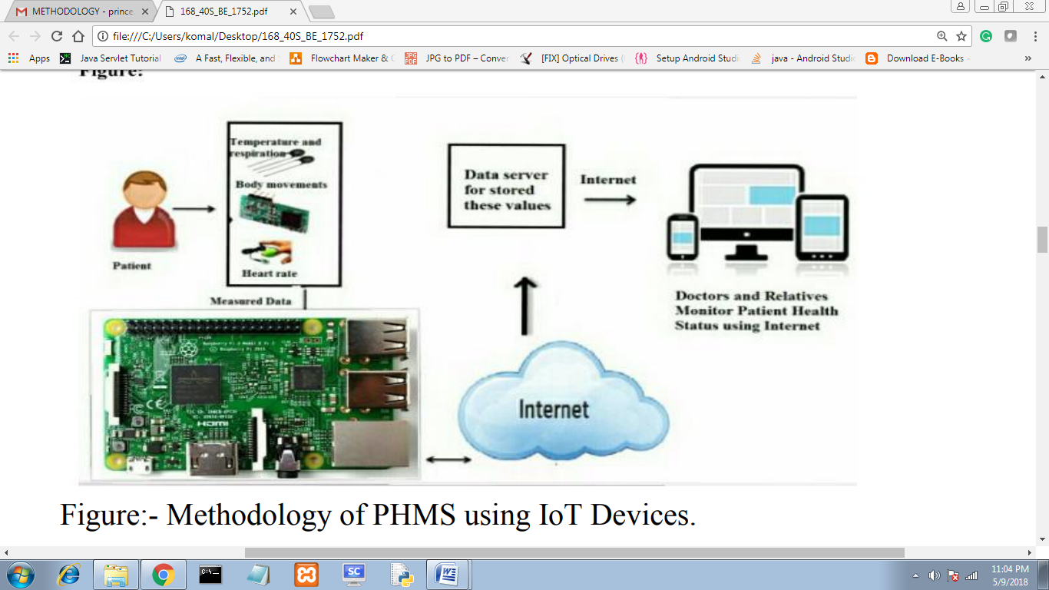

**Figure 3.1: Methodology of Problem solving using IoT Devices.**

In this project we have blood pressure, HRV and heart beat readings which are monitored using pulse sensor. These sensors signals are send to NodeMcu via amplifier circuit and signal conditioning unit (scu), because the signals level are low (gain), so amplifier circuit is used to gain up the signal and transmit the signals to the NodeMcu. Here patient’s blood pressure , HRV and heart rate is measured using respective sensors and it can be monitored in the screen of computer using Node Mcu as well as monitoring through anywhere in the world using internet source. The proposed method of patient monitoring system monitors patient’s health parameters using Raspberry Pi. After connecting internet to the NodeMcu it acts as a server. Then the server automatically sends data to the website. Using IP address anybody can monitor the patient’s health status anywhere in the world using laptops, tablets and smart phones. If these parameters goes abnormal it will automatically sends alert SMS to the doctors and relatives.

**3.3 Outcome**

All in all, this project achieved a lot of its goals. The project implemented a low cost, low power heart rate monitoring with and alarm system using microcontroller technology. The value of health care services lies in their capacity to improve health outcomes for individuals and populations.

**Lists of accomplishments include:**

1. Health outcomes are broadly conceptualized to include clinical measures of disease progression, patient-reported health status or functional status, satisfaction with health status or quality of life, satisfaction with services, and the costs of health services.

2. Adequately acquiring biological signal such as Heart Rate Variability (HRV), Beats Per Minute (BPM) readings through pulse detection sensor. Cloud based visualization and patient-reported health status based on HRV and BPM using Data Analytics.

3.Alert messages to family members when the health status is not normal through web application status display and emergency text notification.

4. If an individual is prone to sudden heart attack, Piezo-electric buzzer will alert the public around using functional notification and alarm system

**3.4 Application**

**3.4.1 Tachycardia**

Tachycardia refers to a heart rate that is over the normal range for a particular age group. When the heart beats at a faster rate, it works inefficiently to provide blood to the rest of the body, thus providing less blood at a given time [8].We will have a table of normal heart rate range for every age group coded in our system. Thus we will compare a person’s resting heart rate reading with their age (from their user profile) and compare with the table to assess if they are suffering from Tachycardia. Tachycardia, also called tachyarrhythmia, is a heart rate that exceeds the normal resting rate. In general, a resting heart rate over 100 beats per minute is accepted as **tachycardia** in adults. There are three types of it:

**1. Supraventricular:** This happens when the electrical signals in the organ's upper chambers misfire and cause the heart rate to speed up. It beats so fast that it can’t fill with blood before it contracts. That reduces blood flow to the rest of your body.

**2. Ventricular:** This is a rapid heart rate that starts in your ticker's lower chambers. It happens when the electrical signals in these chambers fire the wrong way. Again, the heart beats so fast that it can’t fill with blood or pump it through the rest of your body.

**3. Sinus tachycardia:** This happens when your heart’s natural pacemaker sends out electrical signals faster than normal. Your ticker beats fast, but it beats the way it should.

**3.4.2 Bradycardia**

When the resting heart rate is lower than usual for a person (less than 50bpm for adults), the heart problem is called as bradycardia [9]. The heart rate going below this level may cause a cardiac arrest in some people, since a lower heart rate means less blood and oxygen being pumped to the heart. We will implement the above mentioned fact to compare a person’s averaged resting heart rate with the threshold of 50bpm to infer if they might be suffering from Bradycardia. It is a sign of a problem with the heart's electrical system, heart beats less than 60 bpm, it is slower than normal

**3.4.3 Cardiovascular mortality**

Recent studies have confirmed the fact that resting heart rate is an independent predictor of cardiovascular mortality in men and women with and without any diagnosed chronic disease [10]. In a study of 25,000 patients with cardiac diseases, resting heart rate has been found to be a strong indicator of a person’s cardiac health [11]. It was found that patients with a resting heart rate of greater than 83bpm are prone to rehospitalization as compared with patients with a resting heart rate of less than 62bpm. We plan to implement this feature specially for users who have had a heart attack in past. While filling the user profile, we can provide a check box for “Experienced Cardiac Attack in past”. If the user check’s this box, we will make sure that their hear rate readings are cross checked against the 62bpm to 83bpm range, as studied in the [11]. For all the three cases of tachycardia, bradycardia and cardiovascular mortality, we plan to provide a single button in our software system, which users can click to get results (more details in design document). When the user clicks this button, the system will compare their resting heart rate readings for the above mentioned criterions and display on the screen whether the user’s heart is normal or whether it is suffering from tachycardia, bradycardia or cardiovascular mortality. This will be displayed in the form of simple text so that it is easy for the user to comprehend. Users do not need any special knowledge or skills about heart rate variations, our system will do all the calculations for them.

**3.4.4 Hypertension**

Hypertension is another name for high blood pressure. It can lead to severe complications and increases the risk of heart disease, stroke, and death. Normal blood pressure is 120 over 80 mm of mercury (mmHg), but hypertension is higher than 130 over 80 mmHg. Acute causes of high blood pressure include stress, but it can happen on its own, or it can result from an underlying condition, such as kidney disease. Unmanaged hypertension can lead to a heart attack, stroke, and other problems. Heart rate constantly ranging from 100-200.

**3.4.5 Cerebrovascular disease**

Cerebrovascular disease refers to a group of conditions that can lead to a cerebrovascular event, such as a stroke. These events affect the blood vessels and blood supply to the brain. If a blockage, malformation, or hemorrhage prevents the brain cells from getting enough oxygen, brain damage can result. Cerebrovascular diseases can develop in various ways, including [deep vein thrombosis](https://www.medicalnewstoday.com/articles/153704.php) (DVT) and [atherosclerosis](https://www.medicalnewstoday.com/articles/247837.php), where plaque builds up in the arteries.[Stroke](https://www.medicalnewstoday.com/articles/7624.php), [transient ischemic attack](https://www.medicalnewstoday.com/articles/164038.php), [aneurysms](https://www.medicalnewstoday.com/articles/156993.php), and vascular malformations are all types of cerebrovascular disease. Other examples include a narrowing or blockage in the carotid, intracranial, or vertebral arteries, known as stenosis. In this the heart rates of 200 bpm or more can precipitate heart failure.

# 3.4.6 Arrhythmia

An arrhythmia is an irregular heart rhythm. An arrhythmia can occur with a normal heart rate or with fast or slow heart rates. Causes may include coronary artery disease, heart attack, heart surgery, blood imbalances, and more. There are many types of arrhythmias including atrial fibrillation and atrial flutter. Treatments include medications and lifestyle changes, cardioversion, pacemakers, ICDs, and surgery.

**3.5 Hardware Resources Required**

**3.5.1. ESP8266 NodeMCU WiFi Devkit.**

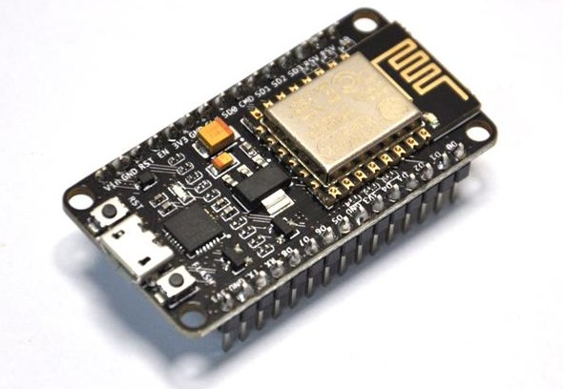

**Figure 3.2: NodeMCU second generation dev kit (v. 1.0)**

The ESP8266 is the name of a micro controller designed by Espressif Systems. The ESP8266 itself is a self-contained WiFi networking solution offering as a bridge from existing micro controller to WiFi and is also capable of running self-contained applications.This module comes with a built in USB connector and a rich assortment of pin-outs. With a micro USB cable, you can connect NodeMCU devkit to your laptop and flash it without any trouble, just like Arduino. It is also immediately breadboard friendly. Espressif’s ESP8266EX delivers highly integrated Wi-Fi SoC solution to meet users’ continuous demands for efficient power usage, compact design and reliable performance in the Internet of Things industry. With the complete and self-contained Wi-Fi networking capabilities, ESP8266EX can perform either as a standalone application or as the slave to a host MCU. When ESP8266EX hosts the application, it promptly boots up from the flash. The integrated high-speed cache helps to increase the system performance and optimize the system memory. Also, ESP8266EX can be applied to any microcontroller design as a Wi-Fi adaptor through SPI / SDIO or I2C / UART interfaces. ESP8266EX integrates antenna switches, RF balun, power amplifier, low noise receive amplifier, filters and power management modules. The compact design minimizes the PCB size and requires minimal external circuitries. Besides the Wi-Fi functionalities, ESP8266EX also integrates an enhanced version of Tensilica’s L106 Diamond series 32-bit processor and on-chip SRAM. It can be interfaced with external sensors and other devices through the GPIOs.

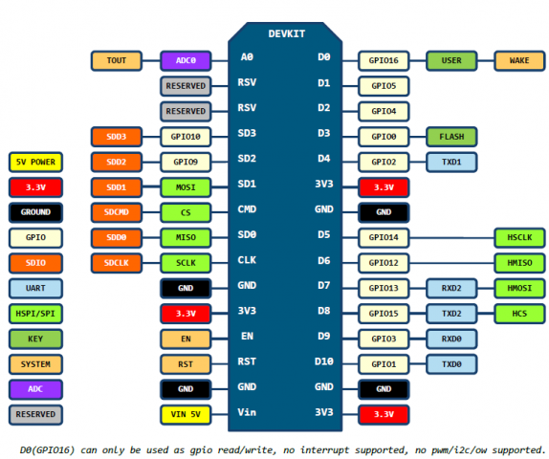 **PIN-DIAGRAM**

**Figure 3.2: Pin diagram for NodeMCU second generation dev kit (v. 1.0)**

**SPECIFIATION:**

**WI-FI :**

|  |  |
| --- | --- |
| Protocols | 802.11 b/g/n |
| Frequency Range | 2.4G ~ 2.5G (2400M ~ 2483.5M) |
| Tx Power | 802.11 b: +20 dBm  802.11 g: +17 dBm  802.11 n: +14 dBm |
| Rx Sensitivity | 802.11 b: –91 dbm (11 Mbps)  802.11 g: –75 dbm (54 Mbps)  802.11 n: –72 dbm (MCS7) |
| Antenna | PCB Trace, External, IPEX Connector,  Ceramic Chip |

**HARDWARE:**

|  |  |
| --- | --- |
| CPU | Tensilica L106 32-bit processor |
| Processor speed | 80~160MHz. |
| Peripheral Interface | UART/SDIO/SPI/I2C/I2S/IR Remote Control  GPIO/ADC/PWM/LED Light &Button | |
| Operating Voltage | 2.5V ~ 3.6V | |
| Operating Current | Average value: 80 mA | |
| Operating Temperature Range | –40°C ~ 125°C | |
| Flash memory attachable | 16MB max (512K normal) | |

**SOFTWARE:**

|  |  |
| --- | --- |
| Wi-Fi Mode | Station/SoftAP/SoftAP+Station |
| Security | WPA/WPA2 |
| Encryption | WEP/TKIP/AES |
| Firmware Upgrade | UART Download / OTA (via network) |
| Software Development | Supports Cloud Server Development / Firmware and SDK for fast on-chip programming |
| Network Protocols | IPv4, TCP/UDP/HTTP/FTP |
| User ConFigureuration | AT Instruction Set, Cloud Server, Android/iOS App |

# Table 3.1: Specifications for NodeMCU second generation dev kit (v. 1.0)

**3.5.2. PULSE SENSOR**

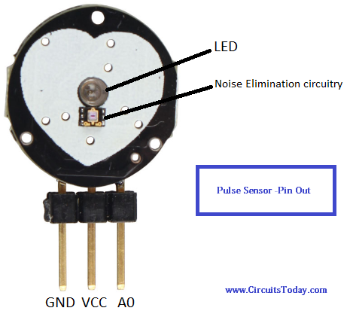

**Figure 3.3: Pulse Sensor**

The Pulse Sensor is the low-cost optical heart rate sensor (PPG) for Arduino and other microcontrollers. The Pulse Sensor is a plug-and-play heart-rate sensor for Arduino. It can be used by students, artists, athletes, makers, and game & mobile developers who want to easily incorporate live heart-rate data into their projects.It essentially combines a simple optical heart rate sensor with amplification and noise cancellation circuitry making it fast and easy to get reliable pulse readings. Also, it sips power with just 4mA current draw at 5V so it’s great for mobile applications. The front of the sensor is the pretty side with the heart logo. This is the side that makes contact with the skin. On the front you see a small round hole, which is where the LED shines through from the back, and there is also a little square just under the LED. The square is an ambient light sensor, exactly like the one used in cellphones, tablets, and laptops, to adjust the screen brightness in different light conditions. The LED shines light into the fingertip or earlobe, or other capillary tissue, and sensor reads the amount of light that bounces back.

**SPECIFICATION:**

|  |  |
| --- | --- |
| Operating Temperature Range | -40 to 85°C |
| Input Voltage Range | 3 to 5.5V |
| Output Voltage Range | 0.3 to 3V |
| Supply Current | 3 to 4mA |

**Table 3.2: Specifications for Pulse Sensor**

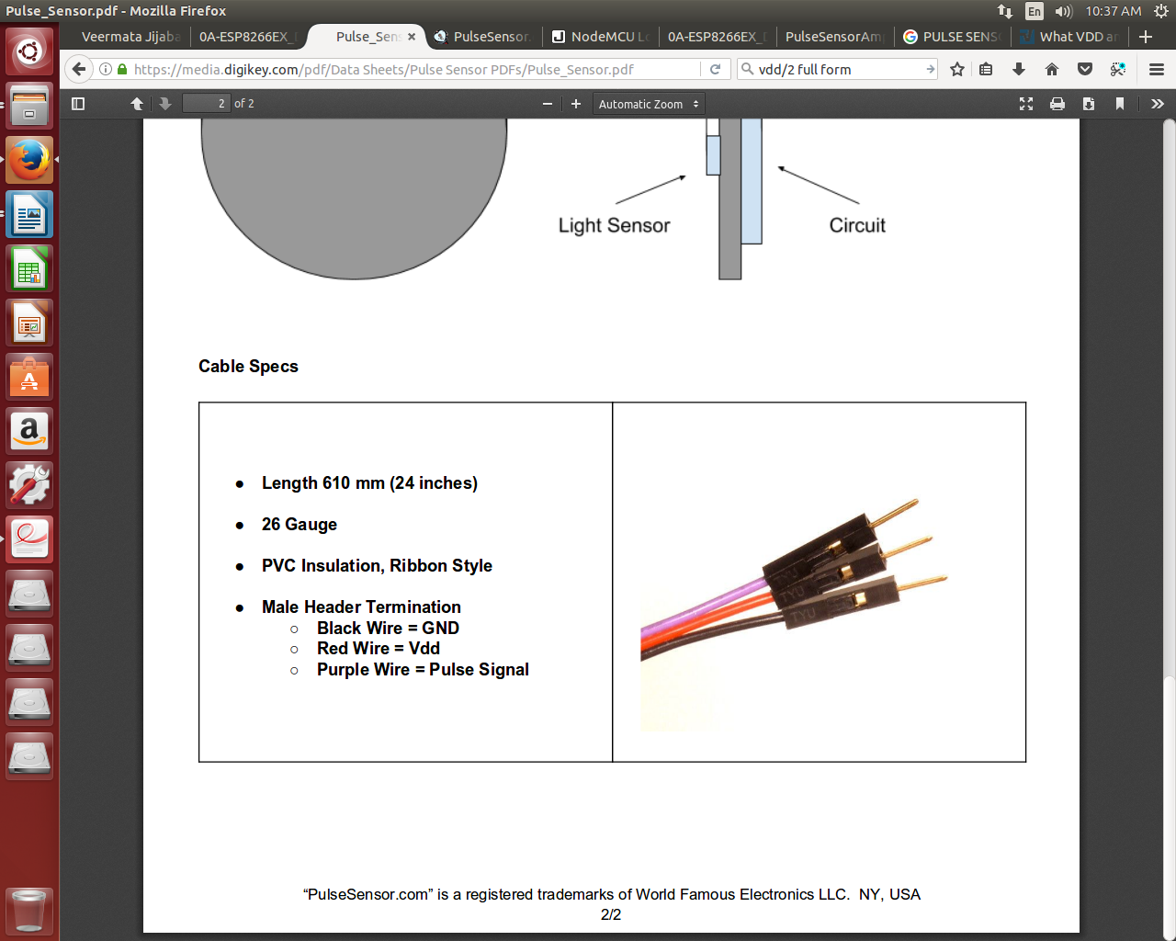**CABLE SPECIFICATION:**

**Figure 3.4: Pulse Sensor cable specification**

**3.5.3 GPS RECEIVER MODULE**

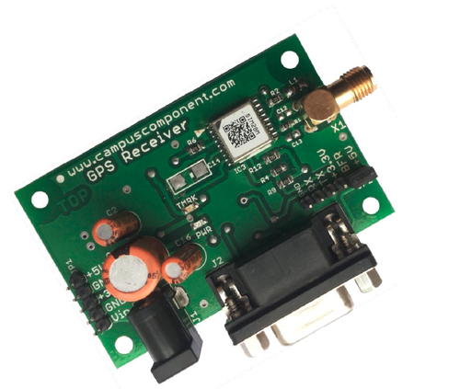

**Figure 3.5: GPS Receiver Module**

A GPS navigation device, GPS receiver, or simply GPS is a device that is capable of receiving information from GPS satellites and then to calculate the device's geographical position.

The main goal is to be used as a part of integrated system, which can be a simple PVT (Position-Velocity-Time) system, for instance, G-mouse, PND (Personal Navigation Device), or complex wireless systems, such as a system with GSM function, a system with Bluetooth function, and a system with GPRS function. The module can be the best candidate for users’ systems as the users’ systems need the careful consideration on the performance, sensitivity, power consumption, and/or size of the module.

**SPECIFICATION:**

|  |  |
| --- | --- |
| **PHYSICAL CONSTRUCTION** |  |
| GPS Board Dimension | L42.5mm*W14.0mm*H6.6mm |
| Receiving frequency | 1575.42MHZ; C/A code |
| Mounting | 6-pin Connector with 1.0mm pitch |
| Construction | Full EMI shielding |
| **ENVIRONMENTAL CONDITIONS** |  |
| Operating: | Temperature:-30 ~ +85 °C  Storage:-40 ~ +85 °C |
| **COMMUNICATION** |  |
| Protocol | NMEA, UBX binary |
| Signal level | UART/USB |
| **INTERFACE CAPABILITY** |  |
| External Antenna | MMCX Edge mount |
| Standard Output Sentences | GGA, RMC, GSV, GSA, VTG, GLL Optional: ZDA |
| **PERFORMANCE** |  |
| Sensitivity | -157dbm (Tracking) |
| SBAS | 1 channel (Support WAAS, EGNOS, MSAS,GAGAN) |
| Receiver architecture | 50 parallel channels |
| Start-up time | 1 sec. typical (hot start)  50 sec. typical (warm start)  50 sec. typical (cold start) |
| Position accuracy(CEP 50) | Autonomous Position Error: 2.5 m |
| Velocity | 500 m/s |
| Altitude | 50,000m (Maximum) |
| Update Rate | 1Hz(Default),2Hz(Flash version) |
| Power Supply | 3V~3.6V |
| Power Consumption | Acquisition: 67mA, Tracking: 47mA |
| Baud Rate | 9600 bps (default)  Optional:4800/19200/38400/115200 bps are adjustable |

**Table 3.2: Specifications for GPS Receiver Module**

**3.5.4 GPS ACTIVE ANTENNA**

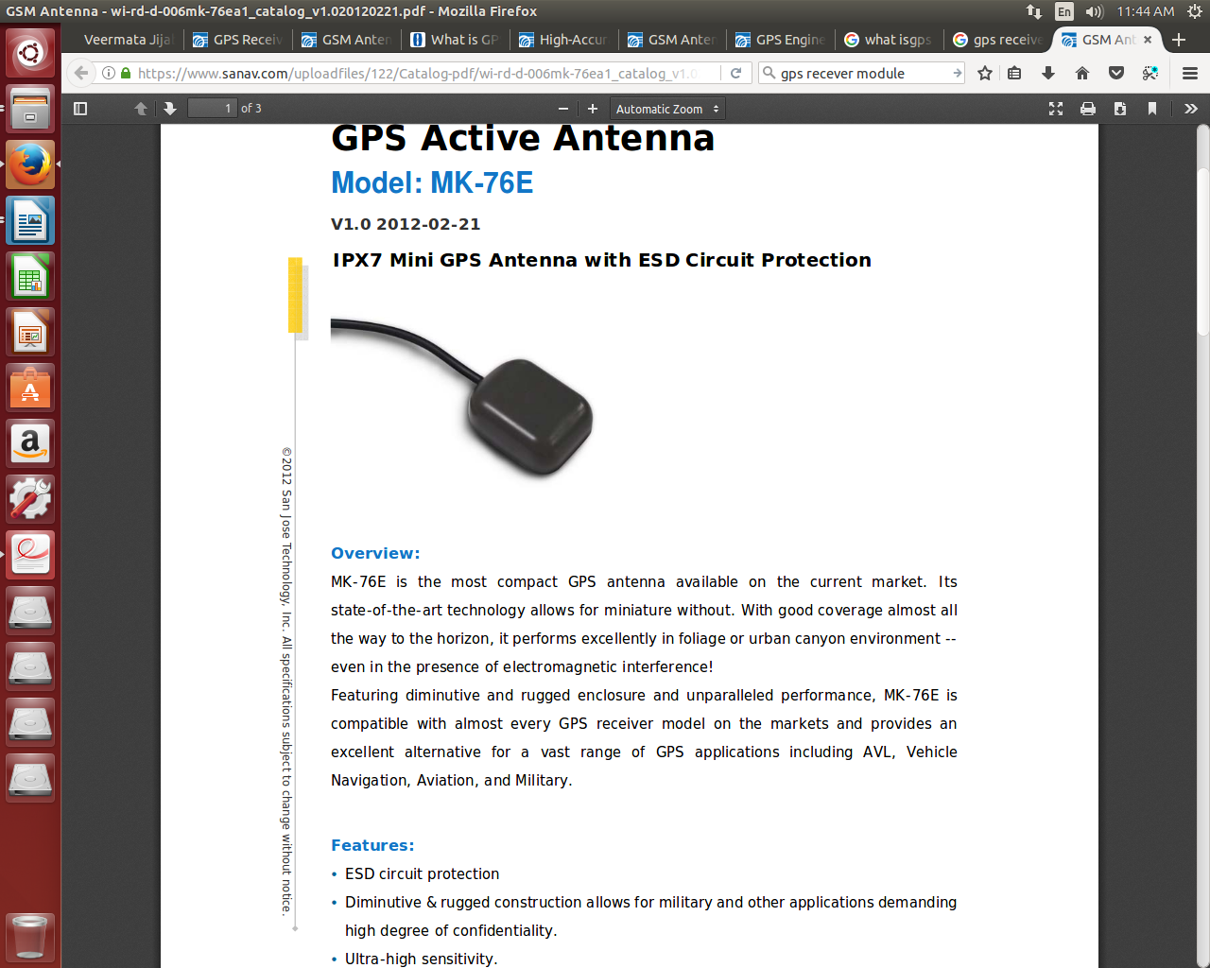

**Figure 3.6: GPS Active Antenna**

MK-76E is the most compact GPS antenna available on the current market. Its state-of-the-art technology allows for miniature without. With good coverage almost all the way to the horizon, it performs excellently in foliage or urban canyon environment --even in the presence of electromagnetic interference! Featuring diminutive and rugged enclosure and unparalleled performance, MK-76E is compatible with almost every GPS receiver model on the markets and provides an excellent alternative for a vast range of GPS applications including AVL, Vehicle Navigation, Aviation, and Military.

**SPECIFICATION:**

|  |  |
| --- | --- |
| Center Frequency | 1575.42 MHz |
| Gain | 27 dB typically |
| Noise Figure | 1.8 dB |
| Band Width | 5 MHz |
| Axial Ratio | 3 dB max. |
| VSWR | 2 dB typically |
| Output Impedance | 50 ohm |

**Table 3.3: Specifications for GPS Active Antenna**

**3.5.5 PIEZOELECTRIC BUZZER**

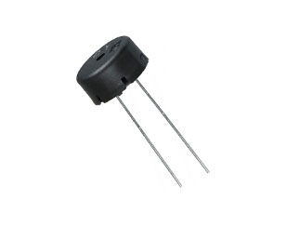

**Figure 3.7: Piezoelectric Buzzer**

A buzzer is a mechanical, electromechanical, magnetic, electromagnetic, electro-acoustic or piezoelectric audio sign alling device. A piezo electric buzzer can be driven by an oscillating electronic circuit or other audio signal source. A click, beep or ring can indicate that a button has been pressed.

**SPECIFICATION:**

|  |  |
| --- | --- |
| Sound Level | 70 dB |
| Voltage | 3 V |
| Frequency | 4 kHz |
| Dimension: | Ø 12.6 mm |

**Table 3.3: Specifications for Piezoelectric Buzzer**

**3.6 SOFTWARE RESOURCES**

**3.6.1 ARDUINO IDE**

The Arduino Integrated Development Environment - or Arduino Software (IDE) - contains a text editor for writing code, a message area, a text console, a toolbar with buttons for common functions and a series of menus. It connects to the Arduino and Genuino hardware to upload programs and communicate with them. Programs written using Arduino Software (IDE) are called sketches. These sketches are written in the text editor and are saved with the file extension .ino. The editor has features for cutting/pasting and for searching/replacing text. The message area gives feedback while saving and exporting and also displays errors. The console displays text output by the Arduino Software (IDE), including complete error messages and other information. The bottom righthand corner of the window displays the conFigured board and serial port. The toolbar buttons allow you to verify and upload programs, create, open, and save sketches, and open the serial monitor.

**3.6.2 XAMPP**

Xampp is an easy to install Apache distribution containing MariaDB, PHP and Perl. It contains: Apache, MariaDB, PHP & PEAR, Perl, ProFTPD, phpMyAdmin, OpenSSL, GD, Freetype2, libjpeg, libpng, gdbm, zlib, expat, Sablotron, libxml, Ming, Webalizer, pdf class, ncurses, mod_perl, FreeTDS, gettext, mcrypt, mhash, eAccelerator, SQLite and IMAP C-Client.XAMPP stands for Cross-Platform (X), Apache (A), MariaDB (M), PHP (P) and Perl (P). It is a simple, lightweight Apache distribution that makes it extremely easy for developers to create a local web server for testing and deployment purposes. Everything needed to set up a web server – server application (Apache), database (MariaDB), and scripting language (PHP) – is included in an extractable file. XAMPP is also cross-platform, which means it works equally well on Linux, Mac and Windows. Since most actual web server deployments use the same components as XAMPP, it makes transitioning from a local test server to a live server extremely easy as well.

**3.6.3 MYSQL.**

MySQL is the world’s most popular open source database for cost-effectively delivering reliable, high-performance and scalable e-commerce, online transaction processing, and embedded database applications. It is an integrated, transaction safe,ACID−compliant database with full commit, rollback, crash recovery, and row-level locking capabilities. MySQL delivers the ease of use, scalability, and high performance, as well as a full suite of database drivers and visual tools to help developers and DBAs build and manage their MySQL applications.

**3.6.4 RUBY ON RAILS.**

Ruby is a pure object-oriented programming language. Ruby on Rails, or Rails, is a server-side web application framework written in Ruby. Rails is a mode-view-controller (MVC) framework, providing default structures for a database, a web service, and web pages. It encourages and facilitates the use of web standard such as JSON or XML for data transfer, and HTML, CSS and JavaScript for display and user interfacing. Ruby on Rails' emergence in the 2000s greatly influenced web app development, through innovative features such as seamless database table creations, migrations, and scaffolding of views to enable rapid application development.

**3.6.5 THINGSPEAK API.**

ThingSpeak, a free internet of things (IoT) platform(55).It is an open source Internet of Things application and API to store and retrieve data from things using HTTP over the Internet or via a Local Area Network(56). With ThingSpeak, the user can create sensor logging applications, location tracking applications, and a social network of things with status updates The primary element of ThingSpeak activity is the channel, which contains data fields, location fields, and a status field. After we create a ThingSpeak channel, we can write data to the channel,process and view the data with MATLAB code, and react to the data with tweets and other alerts. The typical ThingSpeak workflow lets us: 1. Create a Channel and collect data 2. Analyze and Visualize the data 3. Act on the data using any of several Apps

**3.6.6 WEB APPLICATION**

The purpose of the web application is to visualize all the data of the pateint in graphical and statistical manner. From the application, the pateint, care giver, family members will be able to check the pateint’s current personal health condition. The app will display the heart rate, movement activity, IBI, BPM and temperature of the pateint. If the pulse rate and temperature is in the proper range of the pateint's age the app will status the condition as good and healthy. However, if the conditions of the pateint reaches danger level it will status the caregivers and relatives as critical. This will bring the pateint to proper medical attention.For the web based management, an HTTP Apache server with PHP script intercepts all HTTP request through a defined address. The Arduino sends all the data through a POST request which saves the data according to the device id to the MySQL server. A frontend website is developed using jQuery and PHP that provides a clean Graphical User Interface to the end user. The websiteconsists of a graph box on the left that shows live feed of the heart rate. On the right is shows the BPM and IBI. We can find the value of the temperature down below. The data is fetched from the MySQL server to display on the website. The web app requires password log in. Interface of the system.

**CHAPTER 4**

**PROJECT PLAN**

**4.1 Project Estimation**

**4.1.1 Cost Estimation**

|  |  |  |
| --- | --- | --- |
| **SR.NO.** | **Component** | **Cost (IN INR)** |
| 1 | Node MCU | 430 |
| 2 | GPS Module | 800 |
| 3 | Pulse Sensor | 225 |
| 4 | Buzzer | 20 |
| 5 | Connectors (Male, Female) | 75 |
| 6 | Arduino UNO | 350 |
| 7 | WiFi Module ESP8266 | 195 |
| 8 | Breadboard | 80 |
|  | Total | Rs.  2,175 |

**Table 4.1: Project Cost Estimation**

**4.2 Risk Management**

Risks are inherent in any project and should be managed as part of software project management. Proactive risk management is a rational approach and contributes to project success. This is because it involves identifying the risks before they become problems and planning how to mitigate, monitor, and manage them.

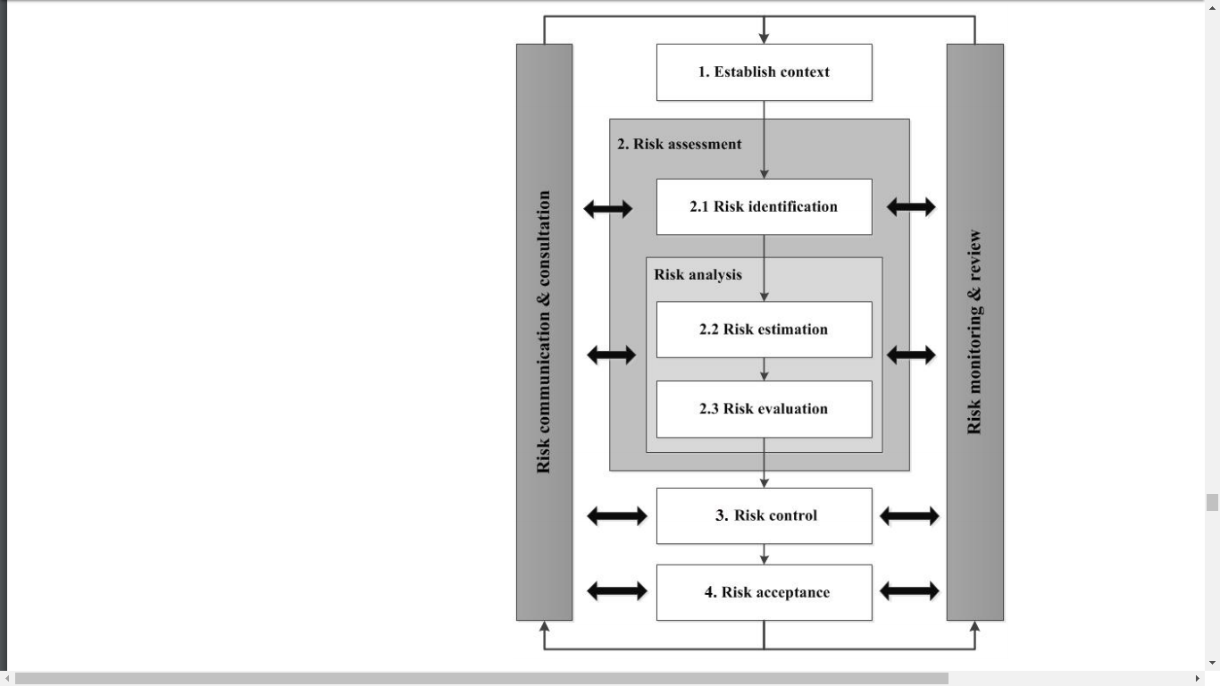

**Figure 4.1: Risk Management Process**

**4.2.2 Risk Identification**

In the proposed system, the patient’s physiological signals are acquired by the sensors attached on the patient body, and are then transmitted to the remote base-station and also a PC for storing and analyzing. In indoor environments, the signal strength of access points can be weakened by 30-90% as it passes through the obstructions (for example, when the two wireless devices or relay nodes are in different rooms, and the door which connects the rooms are closed). With the increasing number of obstructions between the nodes, we can observe more packet loss and more dead spot that will cause a communication disconnection between the patient and the network. So, we have to increase the number of relay nodes within the indoor environments to cover the whole environment, and enhance the reliability for wireless connectivity. In addition, an emergency alert service using short message service (SMS) messaging is also added to the proposed system for emergency responses and rescues.

**4.2.2 Overview of Risk Mitigation and Monitoring**

The safety of this pulse sensor is one of the most important aspect when designing this device. This pulse sensor will be powered by 5V battery so it is safe for people to use. The IR emitter and detector may contain Arsenide which could be hazardous if broken. They are safe under normal conditions. Children should not use this device without an adult’s guidance. It is also important to note that there are many factors that could affect people’s pulse, like emotions, temperature, body position, body size and medication use. This device is not a substitute for professional diagnostics. If your pulse is very high or if you have frequent episodes of unexplained fast heart rates, especially if they cause you to feel weak or dizzy or faint, tell your doctor, who can decide if it’s an emergency.

* 1. **Project Schedule** 
     1. **Project task set**

A task set is the collection of work tasks, milestones, and deliverables. Different setof task proves to be appropriate to different projects. An effective software process is the collection of task sets, each designed to meet the needs of different types of project Task sets are designed to accommodate different types of project and different degrees of rigor.

**Project Types:**

* **Concept development projects:-**That are initiated to explore some new business concept or application of some new technology.
* **New application development:-**Projects that are undertaken as a consequence of a specific customer request.
* **Application enhancement projects:-**That occur when existing software undergoes major modifications to function, performance, or interfaces that are observable by the end-user.
* **Application maintenance projects:-**That correct, adapt, or extend existing software in ways that may not be immediately obvious to the end-user.
* **Reengineering projects:-**That are undertaken with the intent of rebuilding an existing (legacy) system in whole or in part.
  + 1. **Task network**

A task network, also called an activity network, is a graphic representation of the task flow for a project. It is sometimes used as the mechanism through which task sequence and dependencies are input to an automated project scheduling tool.

|  |  |
| --- | --- |
| **Task** | **Description** |
| T1 | System Design |
| T2 | Detailed Design |
| T3 | Database Implementation |
| T4 | Webpage Design |
| T5 | Coding Input Module |
| T6 | Coding Database Related Module |
| T7 | Coding Output Module |
| T8 | Test Planning |
| T9 | Integration |
| T10 | Testing |
| T11 | Network |
| T12 | Final Check |

**Table 4.2: Task network**

* + 1. Timeline Chart

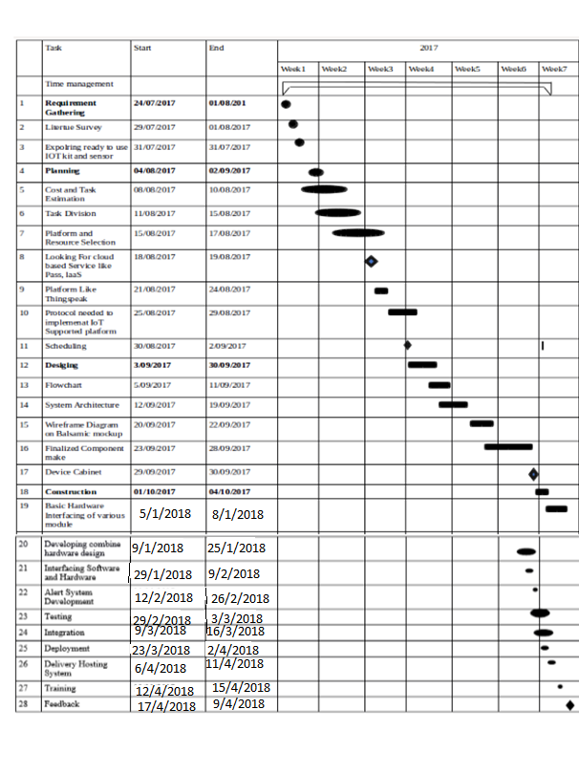

**Table 4.3: Timeline Chart**

**CHAPTER 5**

**SOFTWARE REQUIREMENT SPECIFICATION**

**5.1 Usage Scenario**

**5.1.1 User profiles**

**5.1.2 Use-cases**

* **Actor and Goal**

|  |  |
| --- | --- |
| **Actor** | **Goal** |
| User | The user’s goal is to access the personal health monitoring system to keep track of health condition.  Includes all the people especially patients, athletes who require regular health check-ups. |
| Administrator | The goal of administrator is to retrieve the password for the user. |
| Database | The goal of a database is to store all the readings of each user separately. All the data collected is stored in the database and the user interface has to access the database to retrieve the required information. |

**Table 5.1: Project Use-cases**

* **Use Case Description**

**5.4.5 Design Constraints**

|  |  |  |
| --- | --- | --- |
| **Description Use Case** | **Name** | **Description** |
| UC1 | CreateProfile | Allows a user to create a new profile |
| UC2 | Login | Allows the user to access the system. |
| UC3 | UploadFile | Allows the user to upload a data file to system from a computer. |
| UC4 | ChangeProfile | Allows the user to modify their personal information. |
| UC5 | ViewDailyHeartRate | Allows the user to view the heart rate readings for a day in the form of a line graph. |
| UC6 | ViewDailyCaloriesBurnt | Allows the user to view the calories burnt in a day in the form of a bar graph. |
| UC7 | ViewDailyStressLevel | Allows the user to view the stress levels for a day in the form of a line graph. |
| UC8 | ViewMonthlyHeartRate | Allows the user to view the heart rate readings for a month in the form of a line graph. |
| UC9 | ViewMonthlyCaloriesBurnt | Allows the user to view the calories burnt in a month in the form of a bar graph. |
| UC10 | ViewMonthlyStressLevel | Allows the user to view the stress levels for a month in the form of a line graph. |
| UC11 | ViewHeartCondition | Allows the user to view whether their heart condition is normal, Tachycardia, Bradycardia or cardiac mortality in the form of text. |
| UC12 | CalculateDailyAverageHeartRate | Allows the user to view the average values of heart rate for a day in the form of text. |

**Table 5.2: Project Design Constraints**

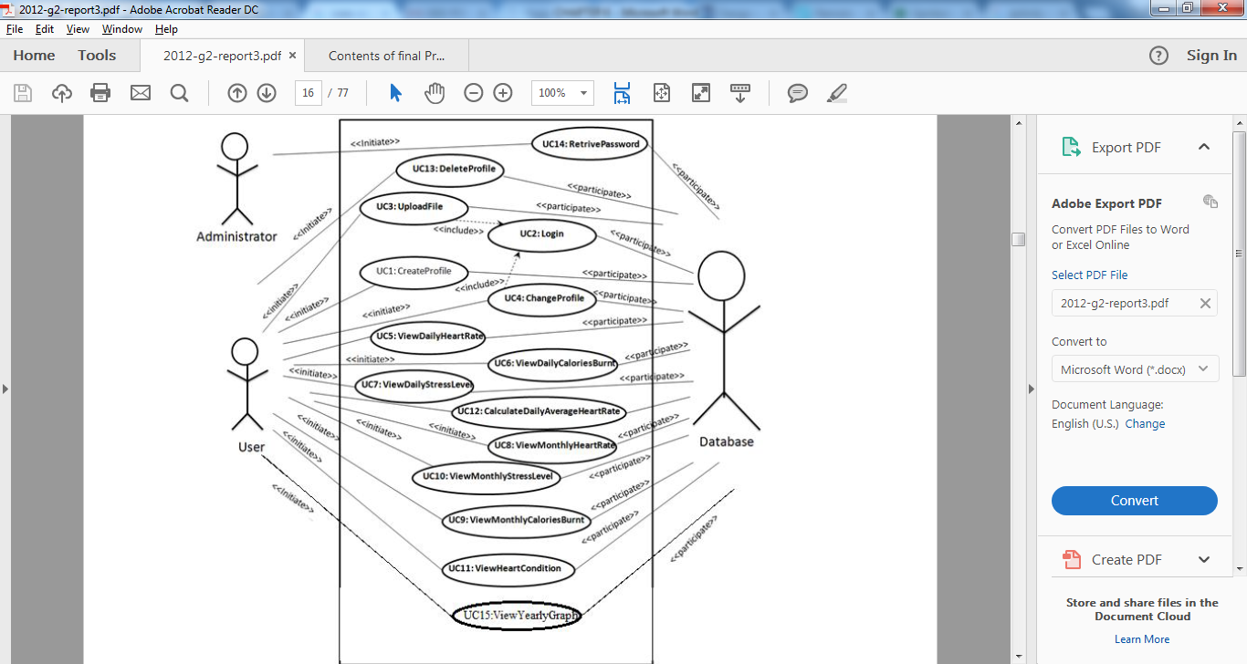

**Figure 5.1:Project Use case Diagram**

**5.3 Data Model and Description**

**5.3.1 Data Description**

**5.3.2 Data objects and Relationships**

**5.4 Functional Model and Description**

**5.4.1 Data Flow Diagram**

* **Data Flow diagram**

A data flow diagram also known as data flow graph or bubble chart is a graphical representation that depicts information flow and the transforms that are applied as data move from input to output.

1. **Level 0 DFD**

A level 0 DFD, also called a fundamental system model or a context model, represents the entire software element as a single bubble with input and output data indicated by incoming and outgoing arrows, respectively.

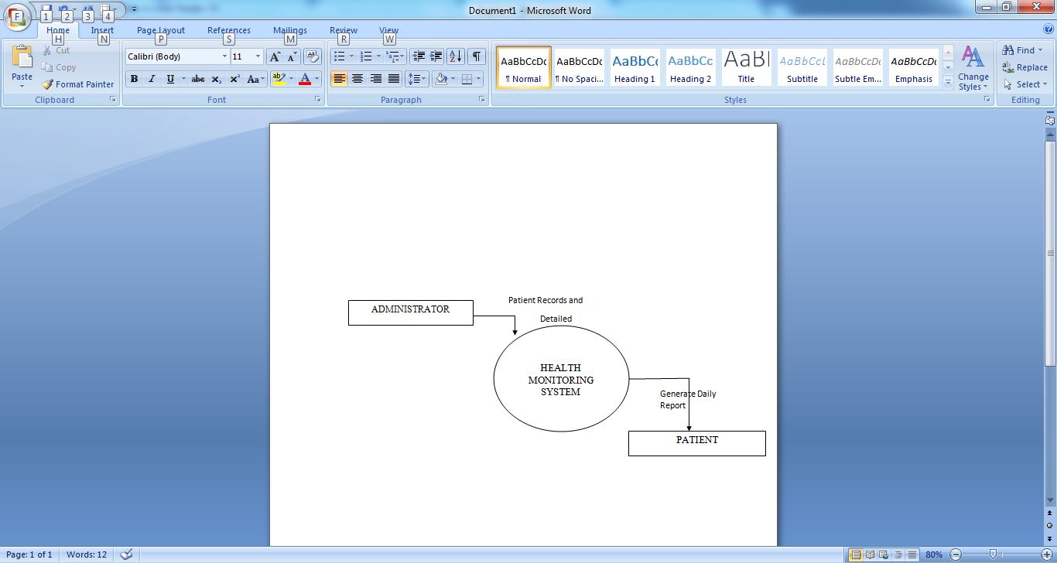

**Figure 5.2:Project DFD Level 0**

1. **FIRST LEVEL DATA FLOW DIAGRAM**

A level 1 DFD might contain five or six bubbles with interconnecting arrows. Each of the processes represented at level 1 is a sub function of the overall system depicted in the context model.

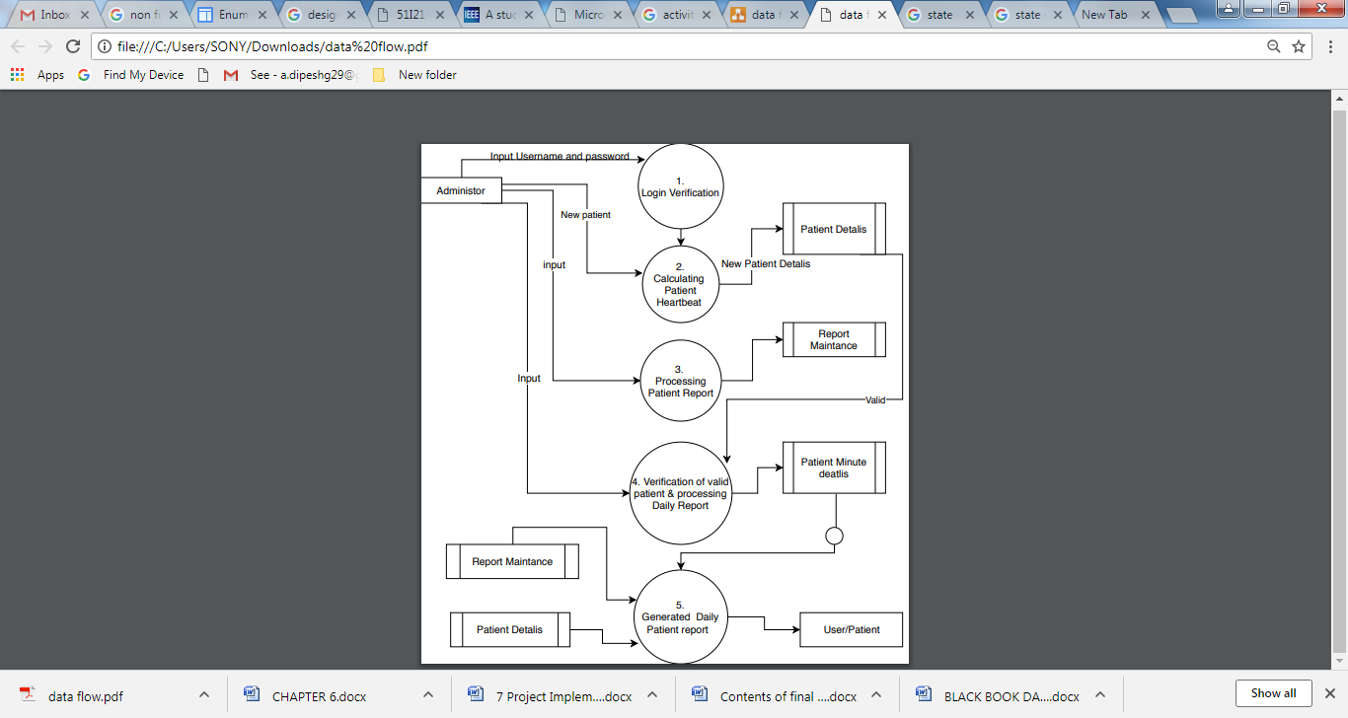

**Figure 5.3:Project First Level DFD Diagram**

**5.4.2 Activity Diagram**

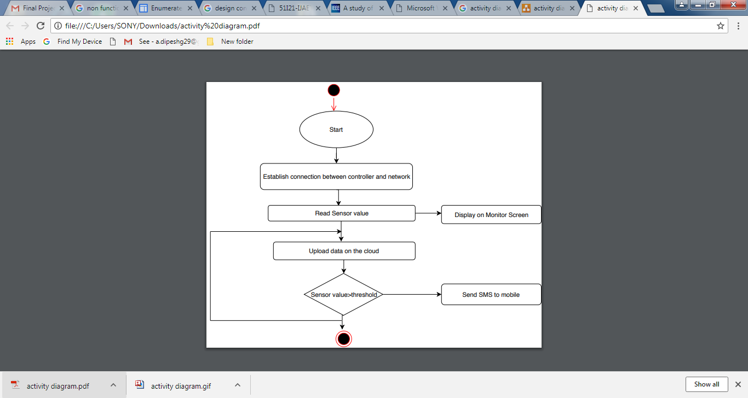

**Figure 5.4:Project Activity Diagram**

**5.4.3 Non Functional Requirements**

**No. of Users that can simultaneously use application:** The E-BAND can be used by an individual one at a time. But the patient’s health status data can be viewed by multiple users (doctors & family members).

**Amount of information to be handled:** Real-time information, patient’s daily reports.

**Availability of system:** The system should be available 24*7 with a downturn once in a month

**Time Complexity:** The system responds within seconds.

**Reliability and cost:** The system can be reliable if sensors predict accurate data. Cost of the system is Rs. 2,095.

**5.4.4 Sequence Diagram**

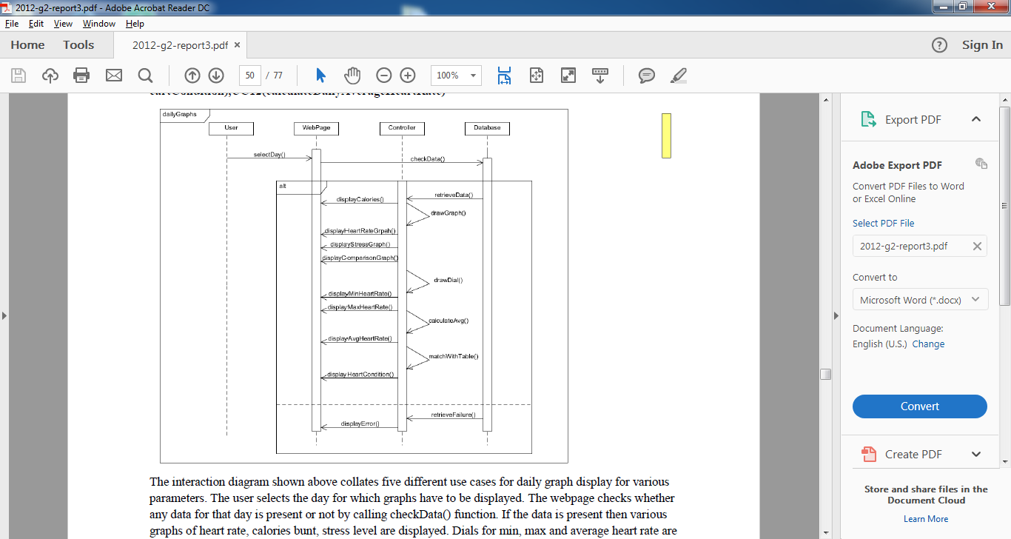

**Figure 5.5:Project Sequence Diagram**

The interaction diagram shown above collates five different use cases for daily graph display for various parameters. The user selects the day for which graphs have to be displayed. The webpage checks whether any data for that day is present or not by calling checkData() function. If the data is present then various graphs of heart rate, calories bunt, stress level are displayed. Dials for min, max and average heart rate are displayed along with the text for daily heart condition is displayed. Else error message is displayed.

**5.4.6 Software Interface Description**

* The pulse sensor senses the person’s pulse which sends out the data on microcontroller (Node MCU)
* Node MCU is a WiFi integrated model which sends out the data on cloud platform i.e. ThingSpeak
* ThingSpeak performs the data analysis and produces easily interpreted graphical statistical reports in the form of scatter diagram.
* When the patient gets fatal and the threshold value i.e. 80-120 increases the system triggers the heartbeat event on the cloud platform and sends alert messages on the cell phone.
* The alert messages on the cell phone are sent through ClickSend.
* ClickSend is a service provided by the IFTTT interface.
* Patient’s health status report generated can be viewed through E-BAND Health Monitoring System WebApp.

**CHAPTER - 06**

**DETAILED DESIGN DOCUMENT**

**6.1 Introduction**

**6.2 Architectural Design**

**Architectural Styles: 3-Tier:**

The heart monitoring system uses the three- tier architecture. The three tier architecture has, as the name suggests, 3 layers. The Presentation layer which deals with the user interface or the look of the website and it will be a central node of the system. It helps the user to interact the system in a smooth manner giving the ability to understand the results. It helps in processing various logical computations and algorithms which give user an understandable result of the raw data uploaded by the user. The logic tier is the "brain" of our system. It will be sensors of the system.The data tier stores all the user data and also the logic tier retrieves data from this tier for processing.

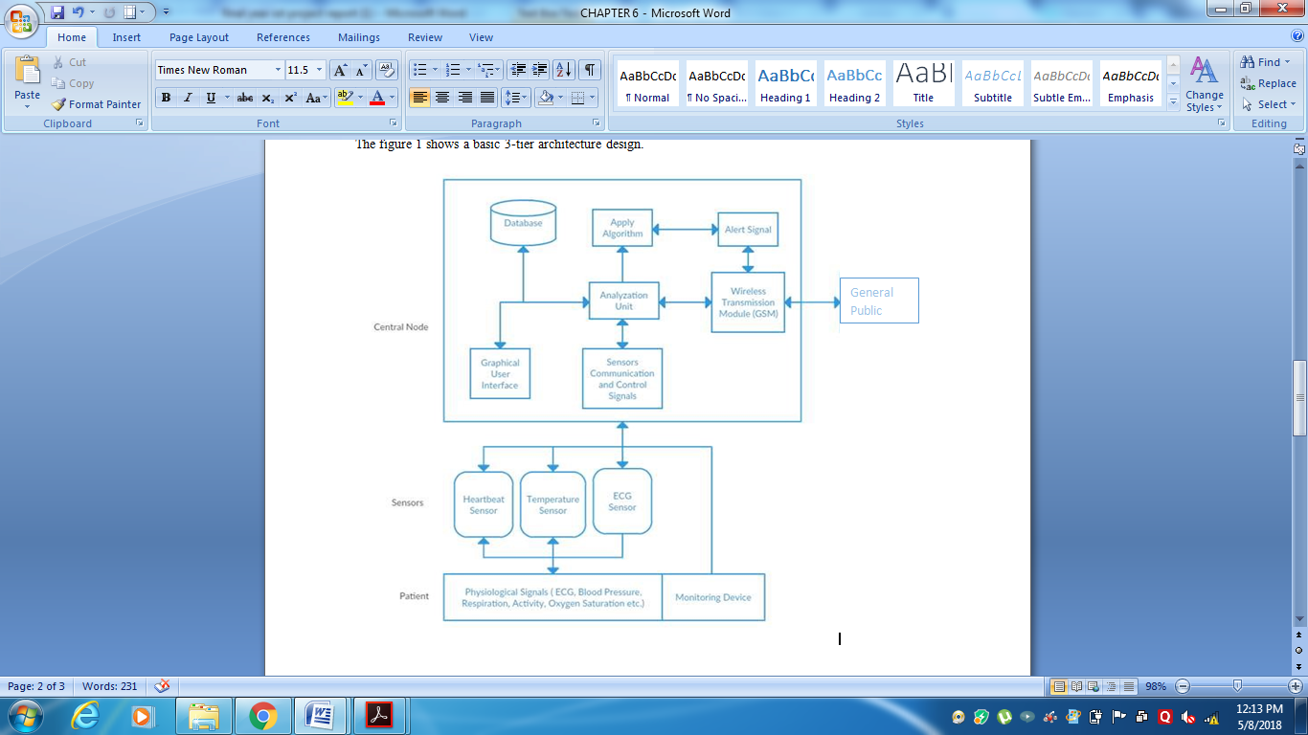

**Figure 6.1: Architecture Design**

**6.3 Data design**

Data design is the first and most important design activity. Here the main issue is to select the appropriate data structure. That is the Data design focuses on the definition of data structures.

The data design describes structures that reside within the software. Attributes and relationships between data objects dictate the choice of data structures.

* **Database Description**

**ADMIN_LOG(For admin login on the web app/portal)**

|  |  |  |  |
| --- | --- | --- | --- |
|  |  |  |  |
|  |  |  |  |
|  |  |  |  |

|  |  |  |  |
| --- | --- | --- | --- |
| **Attribute** | **DataType** | **Constraint** | **Description** |
| Admin | Varchar | Primary Key | System Admin user id |
| Password | Varchar | Unique | System Admin password |

**Patient_Login(For Patient login on the web app/portal)**

|  |  |  |  |
| --- | --- | --- | --- |
| **Attribute** | **DataType** | **Constraint** | **Description** |
| Patient_name | Varchar | Primary Key | User using the portal which has a username in order to login |
| Password | Varchar | Unique | User using the portal which has an unique password in order to login |

**Sign_Up(To Create new patient account on the web app/portal)**

|  |  |  |  |
| --- | --- | --- | --- |
| **Attribute** | **DataType** | **Constraint** | **Description** |
| Firstname | Varchar | Not Null | Patient’s firstname |
| Lastname | Varchar | Not Null | Patient lastname |
| Email_id | Varchar | Not Null | Patient email-id |
| Telephone_no | Int | Not Null | Patient telephone_no |
| Username | Varchar | Not Null | Patient username |
| Password | Varchar | Unique | Patient unique password |
| Confirm password | Varchar | Not Null | Enter confirm password |
| Country | Varchar | Not Null | Enter country name |
| City | Varchar | Not Null | Enter city name |
| State | Varchar | Not null | Enter state name |
| Pincode | Int | Not null | Enter pincode |

**Generate patient Report(Admin will generate patient report)**

|  |  |  |  |
| --- | --- | --- | --- |
| Attribute | DataType | Constraint | Description |
| Patient_id | Varchar | Primary Key | Patient id |
| Report_id | Int | Primary Key | Patient report |

**Table 6.1: Database Description**

**6.4 Component Design**

**6.4.1 Class Diagram**

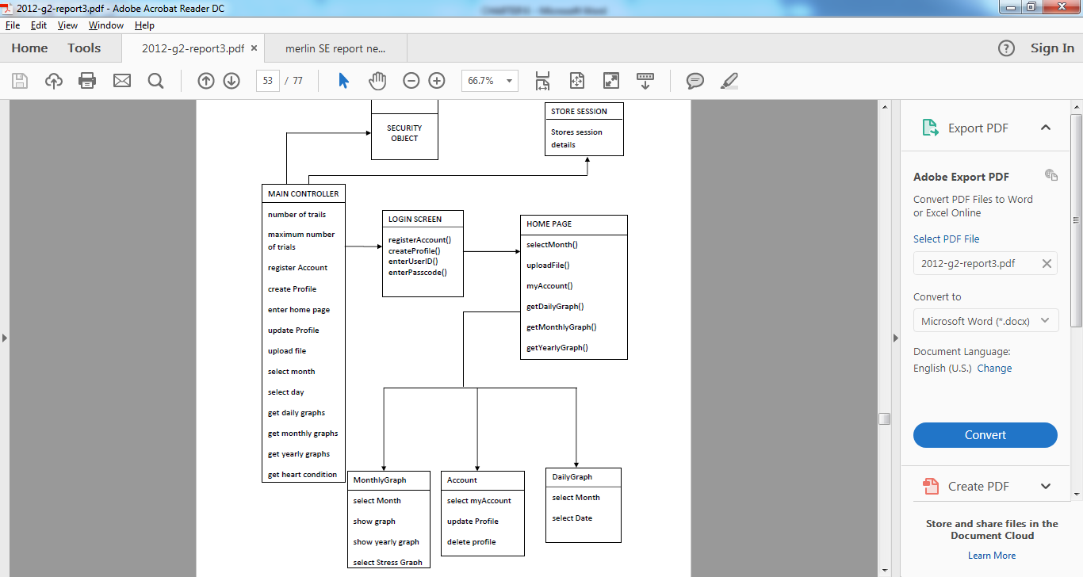

**Figure 6.2: Class Diagram**

* **Data Description**

|  |  |
| --- | --- |
| **Name** | **Documentation** |
| MAIN CONTROLLER | The main controller controls all the activities of the application like login, controlling the activities of the web pages and accessing them. |
| SECURITY OBJECT | It authenticate if proper user is entering the website |
| LOGIN SCREEN | It’s the first page any user will see when they start the system. It will prompt for userId and password. If “new user” then registers profile/create personal profile. |
| HOME PAGE | When the user enters correct credential, the system takes the user to this screen. This includes all the month, account info etc. for the user to check. |
| SESSION STORER | This stores session for a user for each login. |

**Table 6.2: Data Description**

**CHAPTER 7**

**PROJECT IMPLEMENTATION**

**7 Project Implementation**

**7.1 Introduction**

In this chapter the design paradigms for implementation of proposed system are discussed in detail. It also focuses on selection of technologies by judging the feasibility criteria to develop each subsection. The specifications of various components are also described in order to prove the effectiveness of using those. In a nutshell, this chapter gives the detail view of implementing the system. Following Figure shows the context diagram of proposed system to be implemented.

**7.2 Tools and Technologies Used**

* NodeMCU (ESP8266)
* Pulse sensor
* Arduino Studio 2.3
* Android JDK 1.8
* Android JRE 1.8
* ThingSpeak cloud
* Data Analytics
* GPS Module
* Android Mobile
* IFTTT API services
* ClickSend web service
* Word for documentation

**7.3 Methodologies/Algorithm Details**

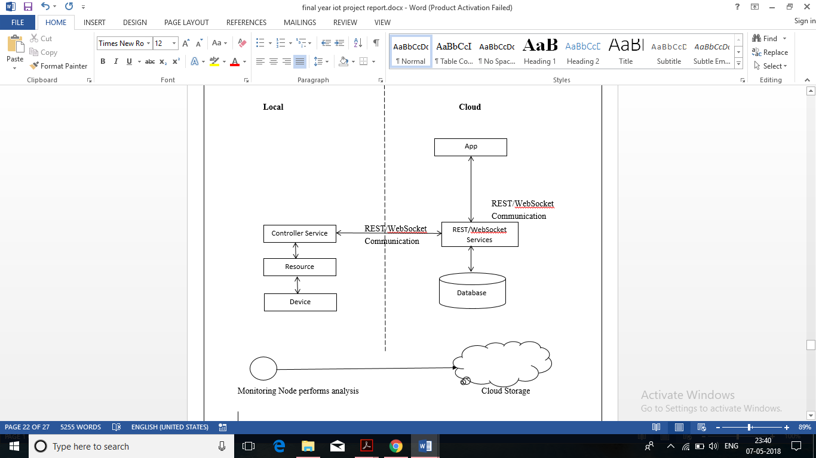

**Figure 7.1: Methodologies/Algorithm Detalis**

**Work Flow:**

The process of developing a complex product that tightly couples hardware devices with high-level software services requires an additional level of planning. For this project, we will exercise a proper product development approach to help you get familiar with the process of creating real-world hardware projects. This method can then be used to plan your own projects and take them to the next level. The following diagram describes a typical prototype development process, which always begins by defining the major goals that you want to achieve with your product.

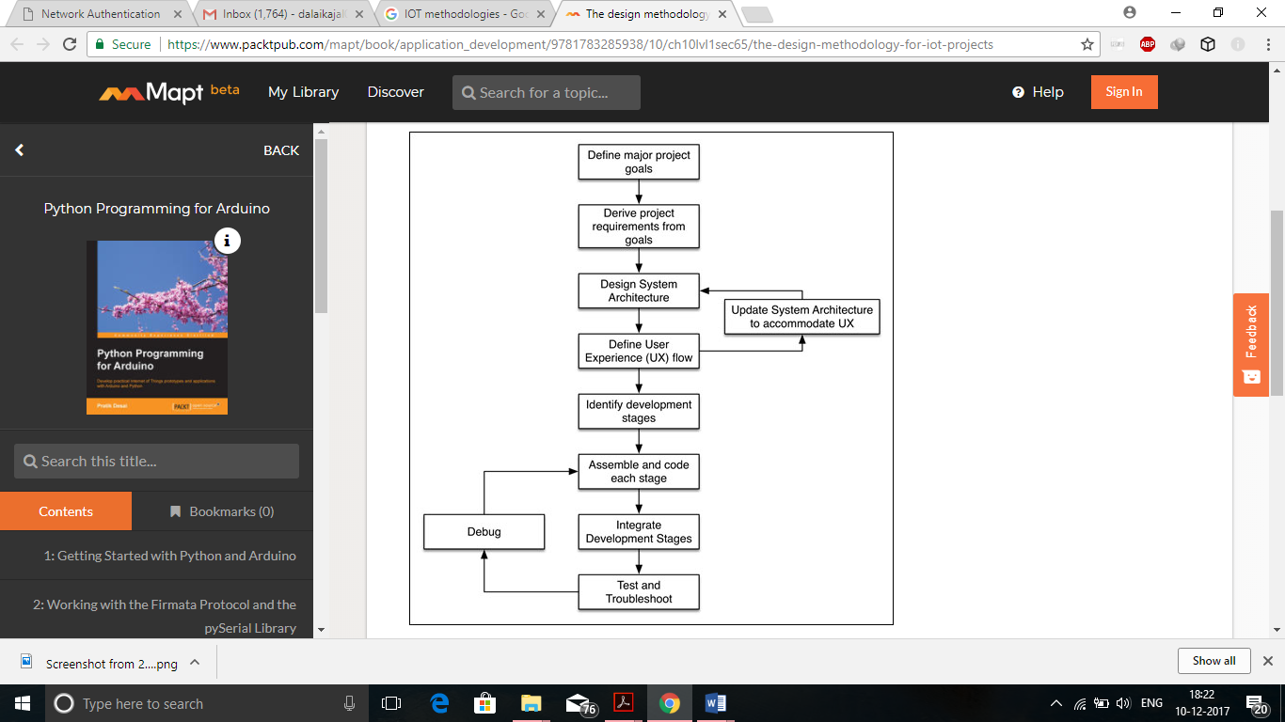

**Figure 7.2: Project Work flow**

**7.3.1 Algorithm 1/Pseudo Code**

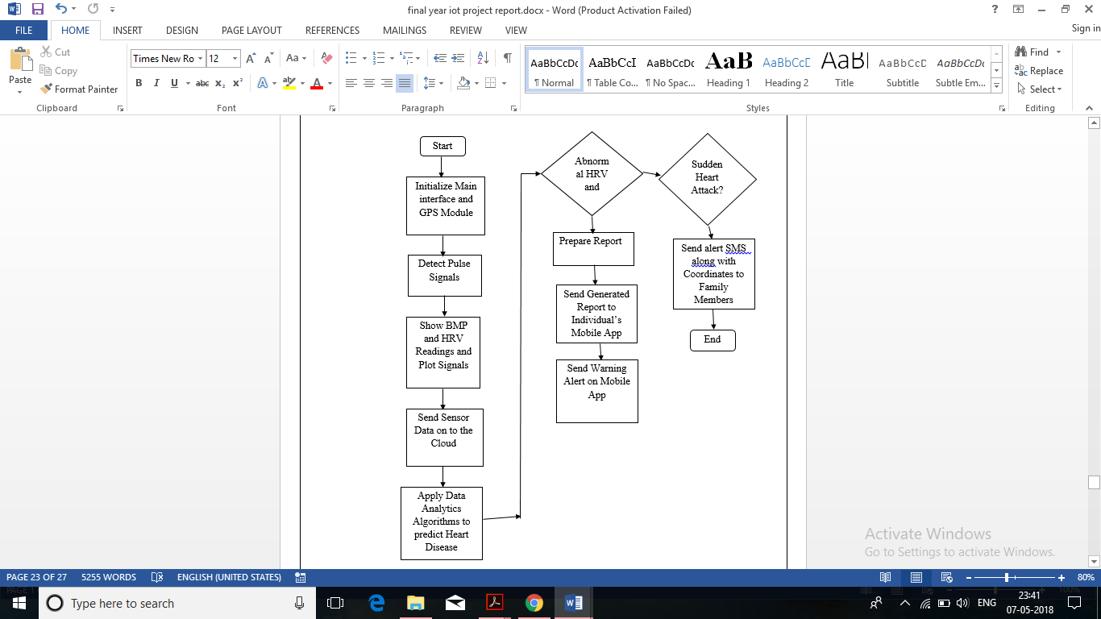

**Figure 7.3: Proposed Algorithm**

**Pseudo Code**

**7.4 Verification and Validation for Acceptance**

|  |  |  |
| --- | --- | --- |
| **Requirement** | **Verification** | **Points** |
| Power Supply  It takes a 9V battery input and output a stable 5V(+/-0.4V) voltage to the rest of circuit and within +/-0.2A of needed current. | Put a voltmeter across the output of regulator circuit, the voltage should be within 5V+-0.4V. The components of the circuit should all work properly without any short or overload. | **15** |
| Pulse Sensor  The pulse sensor should output an accurate periodic analog signal to microcontroller. The periodic wave should correspond to the pulse of the testing people within 5 beats per minute. | The output of the pulse sensor circuit could be verified by using a free software called “Processing” It could sketch the output of the pulse sensor circuit synchronously to a PC screen. Then we can count the pulse per minute based on | **40** |
| Microcontroller  The Microcontroller takes the output of the Pulse Sensor and correctly calculate the beats per Module minute and output to the display module. The beats per minute should be accurate within 5 beats/min | The calculated beats per minute can be displayed on ThingSpeak then we can compare the output of the microcontroller with the waveform generated by pulse module and results from WebApp “Heart Rate”. The testing people can put one hand on pulse sensor and the other hand WebApp. | **20** |
| thingSpeak takes the output of the microcontroller and send it to webapp to display report. Display. | To be compared with the beats per minute value displayed by iPhone App “Heart Rate” by putting one hand on pulse sensor and the other hand on iPhone. | **25** |

**Table 7.1: Verification and Validation for Acceptance**

**CHAPTER 8**

**SOFTWARE TESTING**

**8 Software Testing**

**8.1 Type of Testing Used**

**UNIT TEST CASES**

The primary goal of unit testing is to take the smallest piece of testable software in the application, isolate it from the remainder of the code, and determine whether it behaves exactly as you expect. Each unit is tested separately before integrating them into modules to test the interfaces between modules. Unit testing has proven its value in that a large percentage of defects are identified during its use. Since we are writing codes using PHP we choose to use the PHP Unit Testing. As we identify each class in the component is extensively tested using the PHP unit testing module . In writing the tests before we wrote the class, we have been forced to do a few things. First of all, we had to invent the class’s public API before anything else. It’s worth noting than in Unit Testing and TDD, it is virtually pointless to test private methods (what’s called “Testing State”) since we’re rarely interested in how the code does something as opposed to what the expected end result should be (focus on results, not intermediate state). In a lot of code the result will remain the same, but the working code will evolve over time due to refactoring, new PHP functionality, or system dependent requirements – so testing all this stuff only forces us to constantly rewrite our tests. Once we get down to actual coding, we have all this design work already done and a set of tests which will continually verify the new code we write.

**INTEGRATION TEST CASES**

**Integration testing** is a logical extension of unit testing. In its simplest form, two units that have already been tested are combined into a component and the interface between them is tested. A component, in this sense, refers to an integrated aggregate of more than one unit. In a realistic scenario, many units are combined into components, which are in turn aggregated into even larger parts of the program. The idea is to test combinations of pieces and eventually expand the process to test your modules with those of other groups. Eventually all the modules making up a process are tested together. Beyond that, if the program is composed of more than one process, they should be tested in pairs rather than all at once. **Integration testing** identifies problems that occur when units are combined. By using a test plan that requires you to test each unit and ensure the viability of each before combining units, you know that any errors discovered when combining units are likely related to the interface between units. This method reduces the number of possibilities to a far simpler level of analysis.You can do **integration testing** in a variety of ways and we have chosen the

**Umbrella approach:**

**The umbrella approach** requires testing along functional data and control-flow paths. First, the inputs for functions are integrated in the bottom-up pattern discussed above. The outputs for each function are then integrated in the top-down manner. The primary advantage of this approach is the degree of support for early release of limited functionality. It also helps minimize the need for stubs and drivers. We have chosen this model as the functional issues can be detected early and also as our project requires maintenance, the regression testing scenario would not be a overhead for following this pattern in testing.

**CODE COVERAGE:**

Code coverage is a measure used in software testing. It describes the degree to which the source code of a program has been tested. We have used XDEBUG Extension and it gives us the function coverage statistics as well as statement coverage statistics .We have observed that the function coverage was 100% ,however statement coverage was 60% as many branches would never be executed with any piece of testing .

**8.2 Test Cases and Test Results**

Below are the design of the test cases as per required by out project. These are the basic test cases. We need to check thoroughly that all the test cases are working properly, the screens are displayed in a proper format and there is no discrepancy in displayed graphs. We also need to check the code thoroughly for the correctness of algorithm and control flows.

**1. Test ID : TC1_Login**

|  |  |  |  |
| --- | --- | --- | --- |
| Assumption: the user is at login screen. **Input Requirement** | **Expected Output** | **Pass/Fail** | **Comments** |
| Valid userId ,Password | Login successfully | Pass if the user is able to login and sees the home screen | This is to test that the system allow valid user to enter the website |
| Invalid UserId ,password | Display error message "Invalid userId/Password" | Pass if the user is unable to see the home screen | This test is to determine that invalid user should not enter the website |

**2. Test ID: TC2_Register:**

|  |  |  |  |
| --- | --- | --- | --- |
| Assumption: the user is at the login screen. **Input Requirement** | **Expected Output** | **Pass/Fail** | **Comments** |
| the user enters a userId which is unique | Register successfully | Pass if the user is able to register his UserId password. | This is to test that the system allow only unique user in the system with the unique userID |
| the user enters a userId which is pre-existing | Display error message "User Id already exist. Please choose another ID" | Pass if the user is unable to create a userId | This is to test that the system does not allow two user with the same userID |

**3. Test ID: TC3_Upload**

|  |  |  |  |
| --- | --- | --- | --- |
| Assumption: the user is login and on the upload sensor data screen **Input Requirement** | **Expected Output** | **Pass/Fail** | **Comments** |
| the user tries to load a file with json, .xls, .csv file format and one column of heart reading | file upload successful | Pass if the user is able to upload the file and shown message “Successful upload" | This test is to determine that the system allows only .csv file to be loaded successfully |

**4. Test ID: TC4_viewDailyData**

|  |  |  |  |
| --- | --- | --- | --- |
| Assumption: User is login and at the calendar screen. **Input Requirement** | **Expected Output** | **Pass/Fail** | **Comments** |
| the user clicks on the day to see the uploaded data and report | the user is taken to the day screen and graphs are displayed with proper markings on x-axis and y-axis | Pass if the user is able to see his daily heart rate graph, daily minimum maximum heart rate and stress level. | This test is to determine that the user is able to see his heart graphs properly. |
| the user clicks on the day where no data is uploaded | Display message "no data uploaded" | Pass if the user is unable to see any graph | This test is to determine that the system does not display graph for day when no data is uploaded. |

**5. Test ID : TC5_viewMonthlyData**

|  |  |  |  |
| --- | --- | --- | --- |
| Assumption: User is login and at the calendar screen. **Input Requirement** | **Expected Output** | **Pass/Fail** | **Comments** |
| the user clicks on the month to see the uploaded data and report | the user is taken to the month screen and graphs are displayed with proper markings on x-axis and y-axis | Pass if the user is able to see his monthly heart rate graph, monthly minimum maximum heart rate and stress level. | This test is to determine that the user is able to see his daily heart graphs properly. |
| the user clicks on the month where no data is uploaded | Display message "no data uploaded" | Pass if the user is unable to see any graph | This test is to determine that the system does not display graph for a month when no data is uploaded. |

**6. Test ID: TC6_viewHeartCondition**

|  |  |  |  |
| --- | --- | --- | --- |
| Assumption: the user is at login screen and at the home screen. **Input Requirement** | **Expected Output** | **Pass/Fail** | **Comments** |
| The user clicks on view heart condition. | The user is shown his heart condition. | Pass if the user is able to see his heart condition | This test is to determine that the user is able to see their heart condition properly. |
| the user clicks on view heart condition when no data is uploaded for the month | Display message "no data uploaded" | Pass if the user is unable to see his heart condition | This test is to determine that the system does not display heart condition when no data is uploaded. |

**7. Test ID: TC7_updateProfile**

|  |  |  |  |
| --- | --- | --- | --- |
| Assumption: the user is at login screen and at the “my account” screen. **Input Requirement** | **Expected Output** | **Pass/Fail** | **Comments** |
| The user clicks on update profile and updates proper data. | the user is able to update his profile successfully | Pass if user is able to update his profile | This test is to determine that the system allows the user to update his profile successfully. |
| The user clicks on update profile and updates with incorrect data. | Display message "incorrect format please try again" | Pass if user is unable to update his profile with incorrect data. | This test is to determine that the system allows the user to update his profile successfully with correct format data. |

**Table 8.1: Project Test Cases**

**CHAPTER 9**

**RESULTS**

**9 Results**

**9.1 Outputs (Screen shots)**

**HOME**

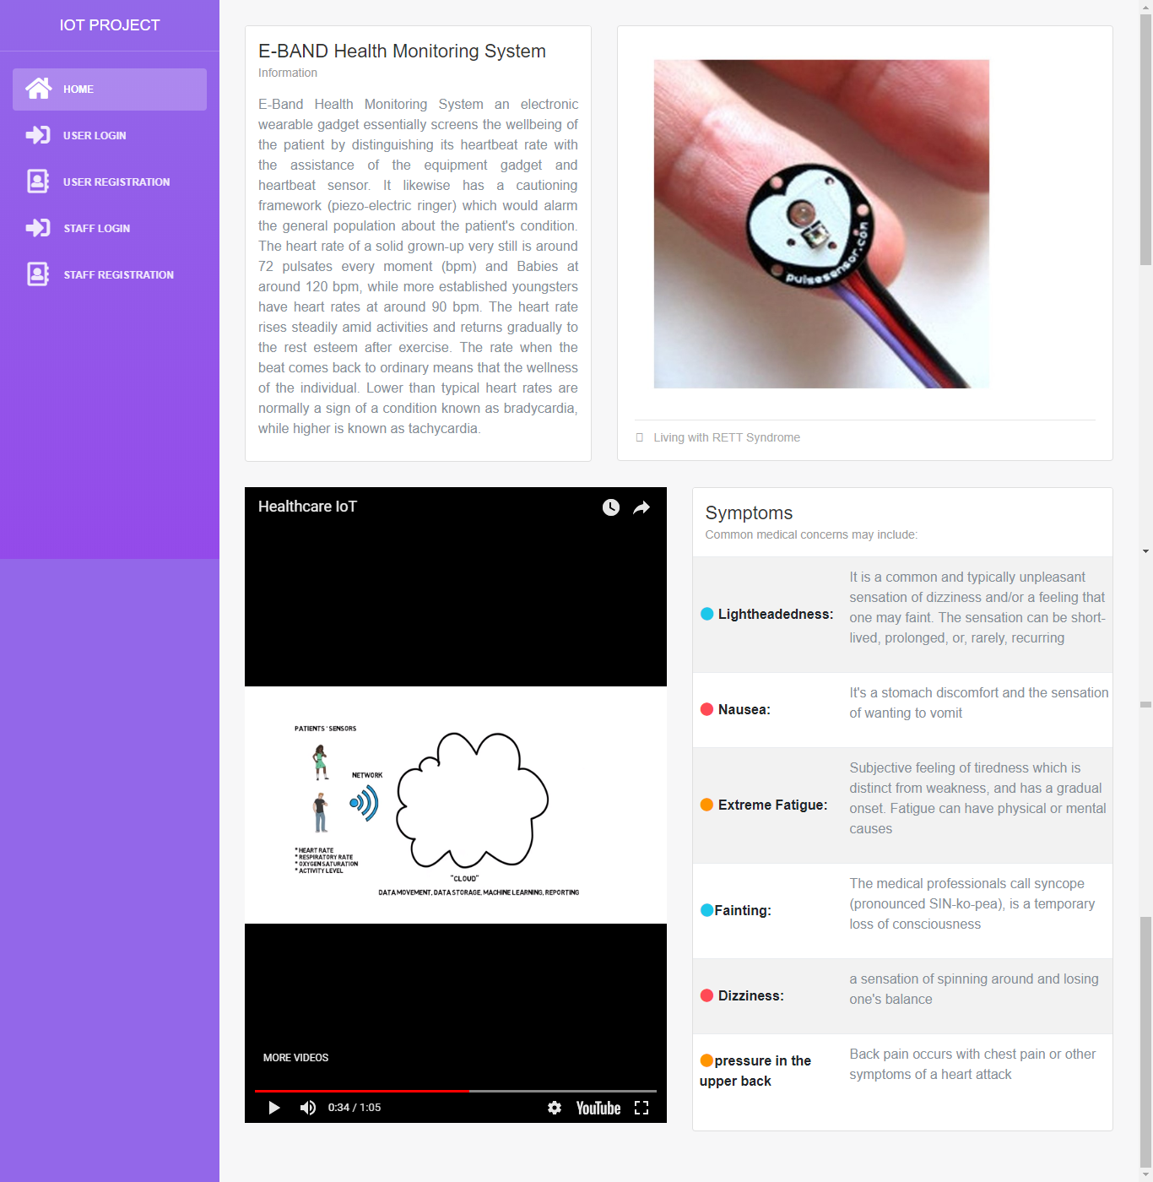

**Figure 9.1:Screenshot of web app home page**

Patient Register

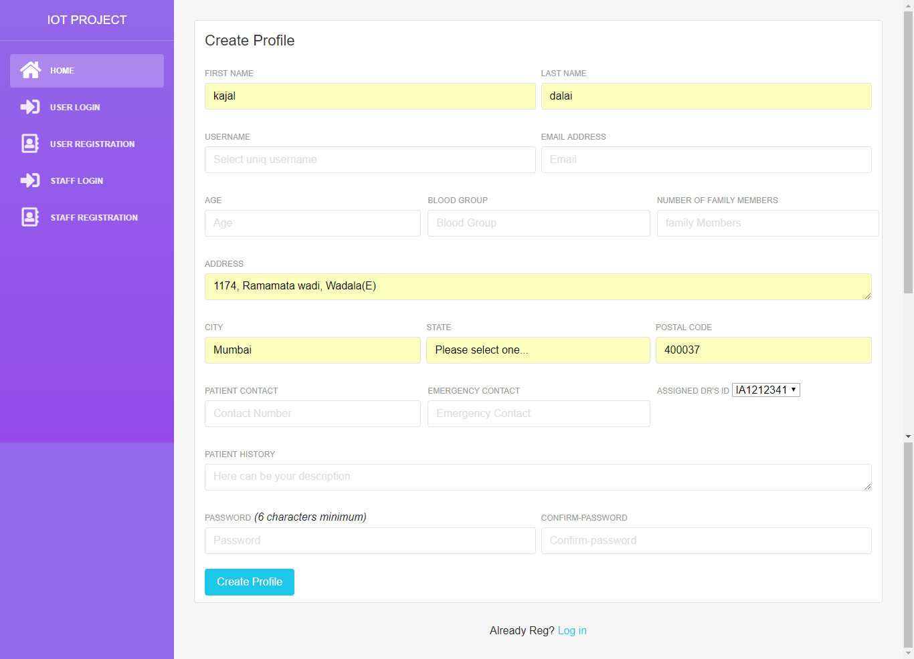

**Figure 9.2:Screenshot of web app Patient Register page**

Patient Login

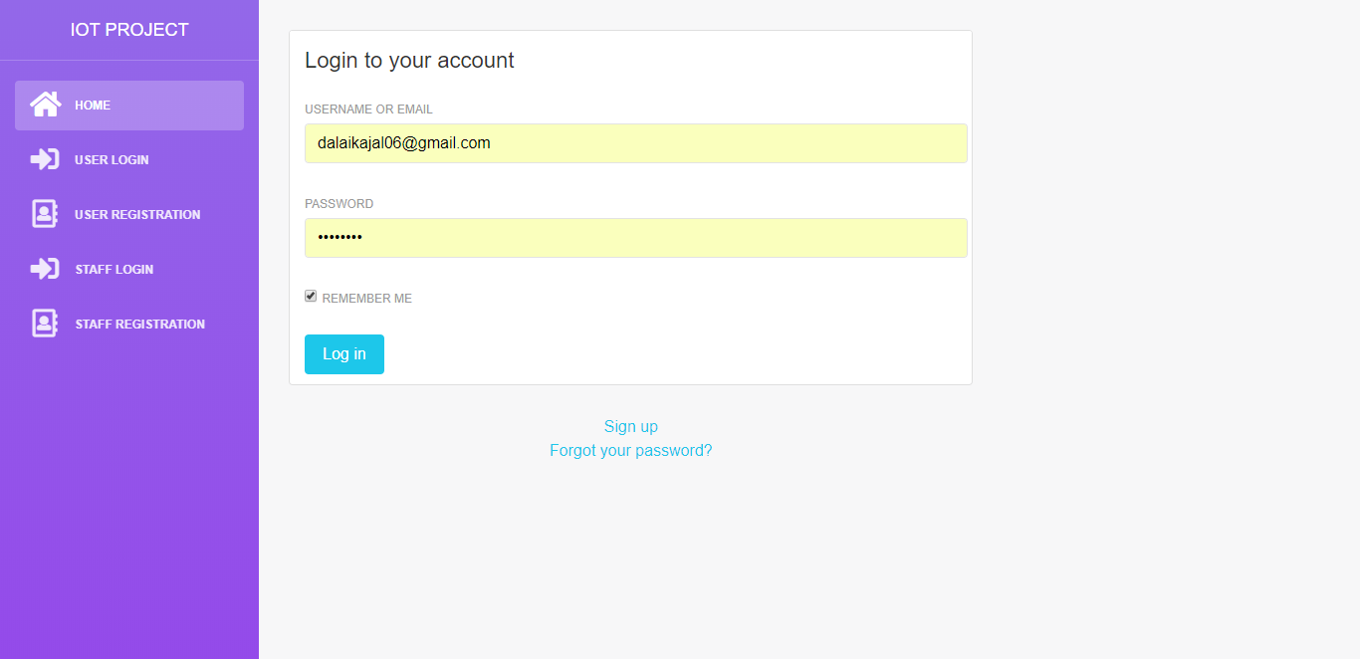

**Figure 9.3:Screenshot of web app Patient Login page**

Staff Register

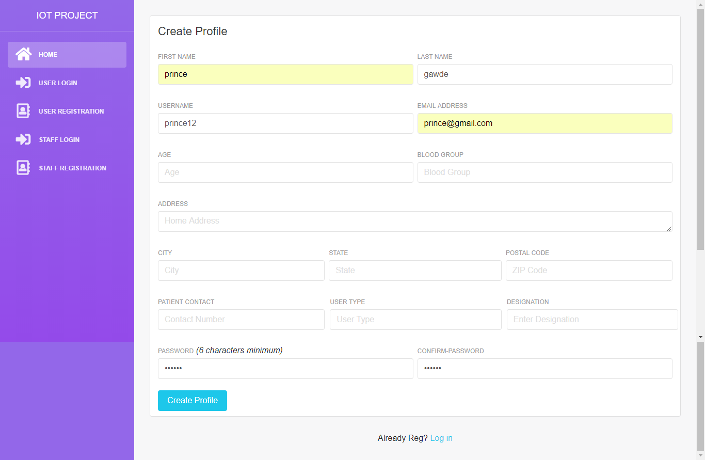

**Figure 9.4:Screenshot of web app Staff Register page**

**Report**

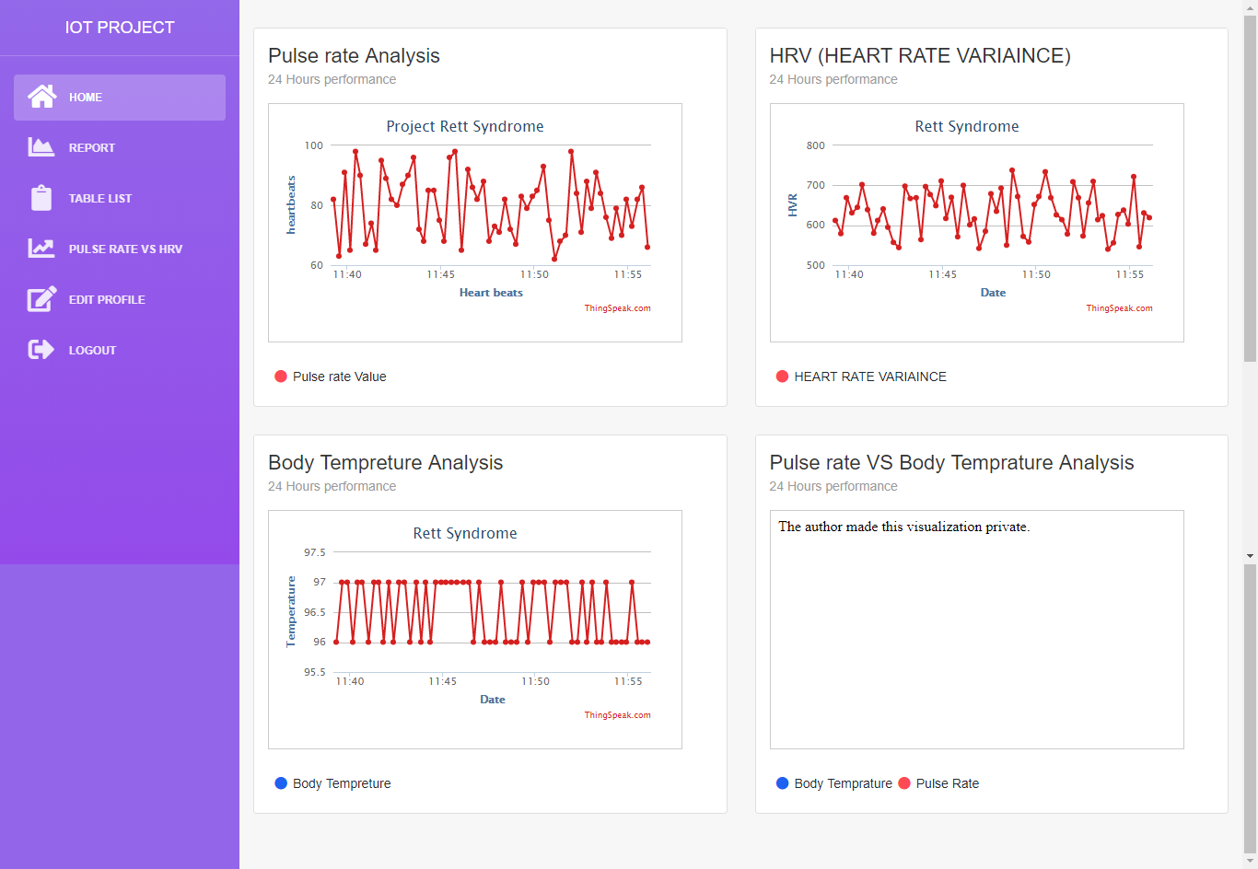

**Figure 9.5:Screenshot of web app Report page**

**Pulse Rate vs HRV**

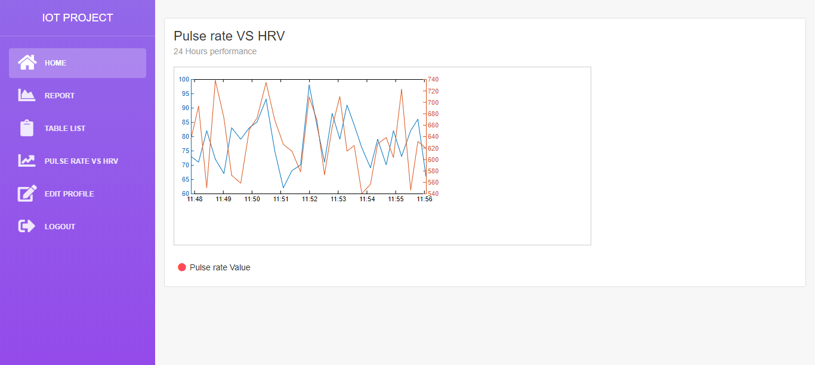

**Figure 9.6:Screenshot of web app Pulse Rate vs HRV page**

**Heart Rate Readings:**

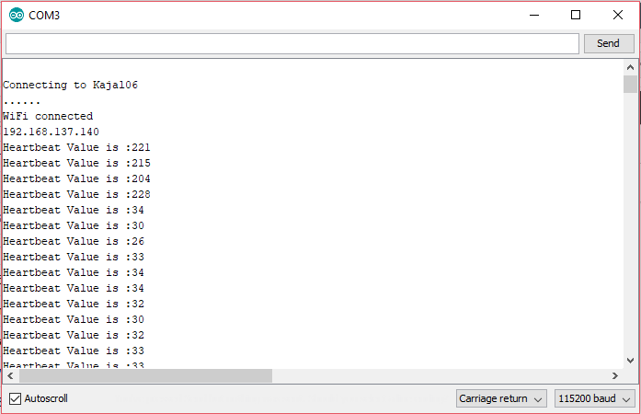

**Figure 9.6: Screenshot of real time Heart Rate Readings**

**ThingSpeak API**

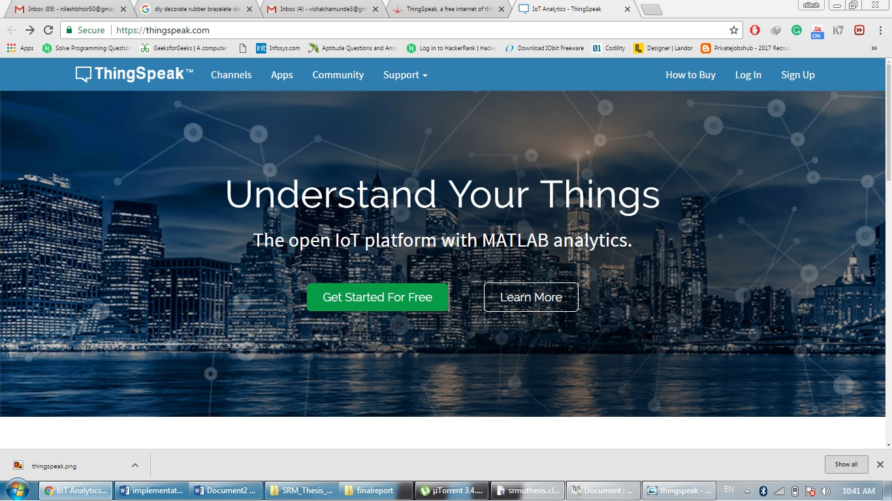

**Figure 9.8: Screenshot of ThingSpeak API**

**ActOn() Module**

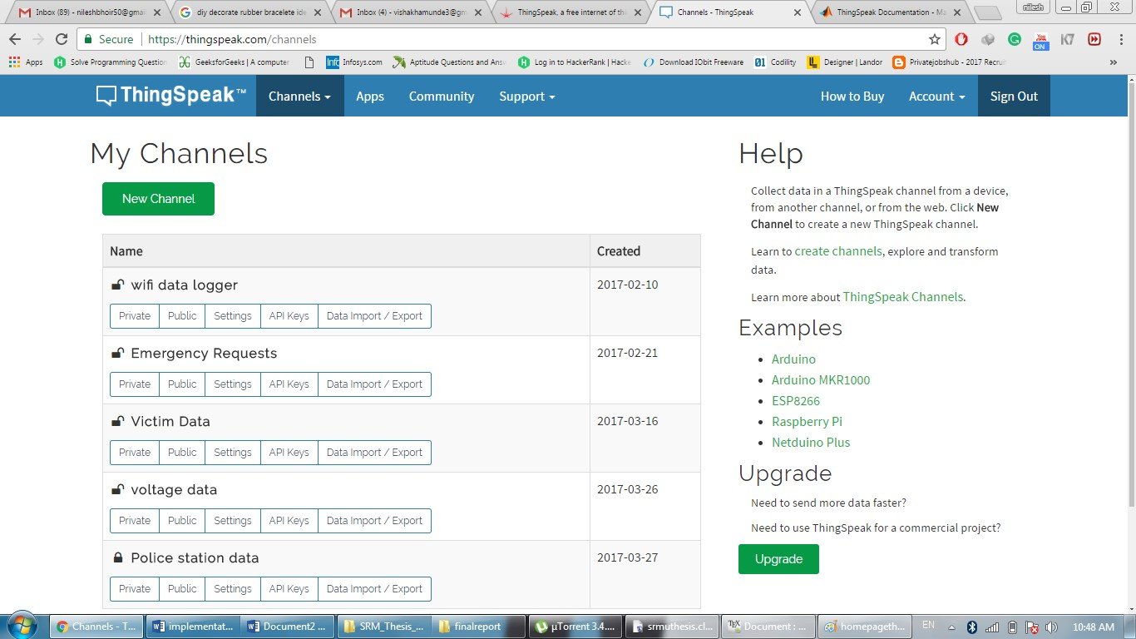

**Figure 9.9: Screenshot of ThingSpeak API ActOn() Module**

**CHAPTER - 10**

**DEPLOYMENT AND MAINTENANCE**

**Deployment and Maintenance**

**10.1Installation and Uninstallation**

**10.1.1 Arduino Software**

**Steps:**

### 1. Download the Arduino Software (IDE)

### 2. Choose the components to install

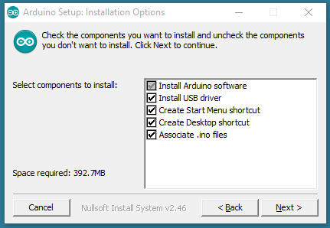

**Figure 10.1: Screenshot of Arduino Installation option**

3. Choose the installation directory (we suggest to keep the default one)

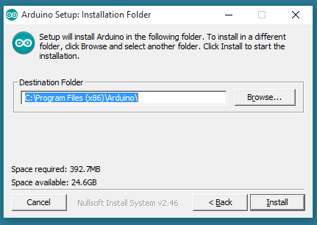

**Figure 10.2: Screenshot of Arduino Installation folder**

4. The process will extract and install all the required files to execute properly the Arduino Software (IDE)

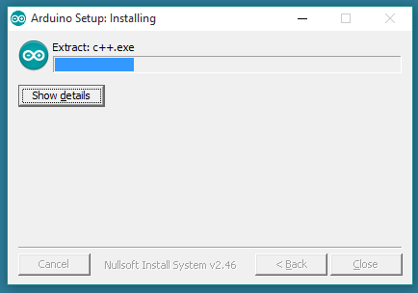

**Figure 10.3: Screenshot of Arduino Installation completion**

* + 1. **Thingspeak API**

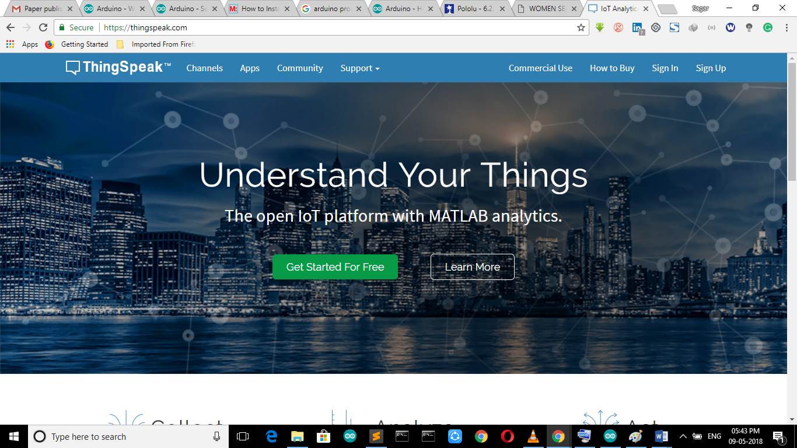  
**Figure 10.4: Screenshot of Thingspeak home page**

ThingSpeak, a free internet of things (IoT) platform(55).It is an open source Internet of Things application and API to store and retrieve data from things using HTTP over the Internet or via a Local Area Network(56). With ThingSpeak, the user can create sensor logging applications, location tracking applications, and a social network of things with status updates The primary element of ThingSpeak activity is the channel, which contains data fields, location fields, and a status field. After we create a ThingSpeak channel, we can write data to the channel, process and view the data with MATLAB code, and react to the data with tweets and other alerts. The typical ThingSpeak workflow lets us:

1. Create a Channel and collect data

2. Analyse and visualize the data

3. Act on the data using any of several Apps

**10.1.3ActOn() Module**

ActOn() acts as middleware between the thingspeak cloud and the police station software. Thinspeak and police station software do not directly interact with each other. Emergency message from ThingSpeak is first checked by ActON after every 15 seconds and the coordinates of the victim received are forwarded to nearest police station. Police incharge information and status of action to be taken is then updated on ThingSpeak by the ActOn module

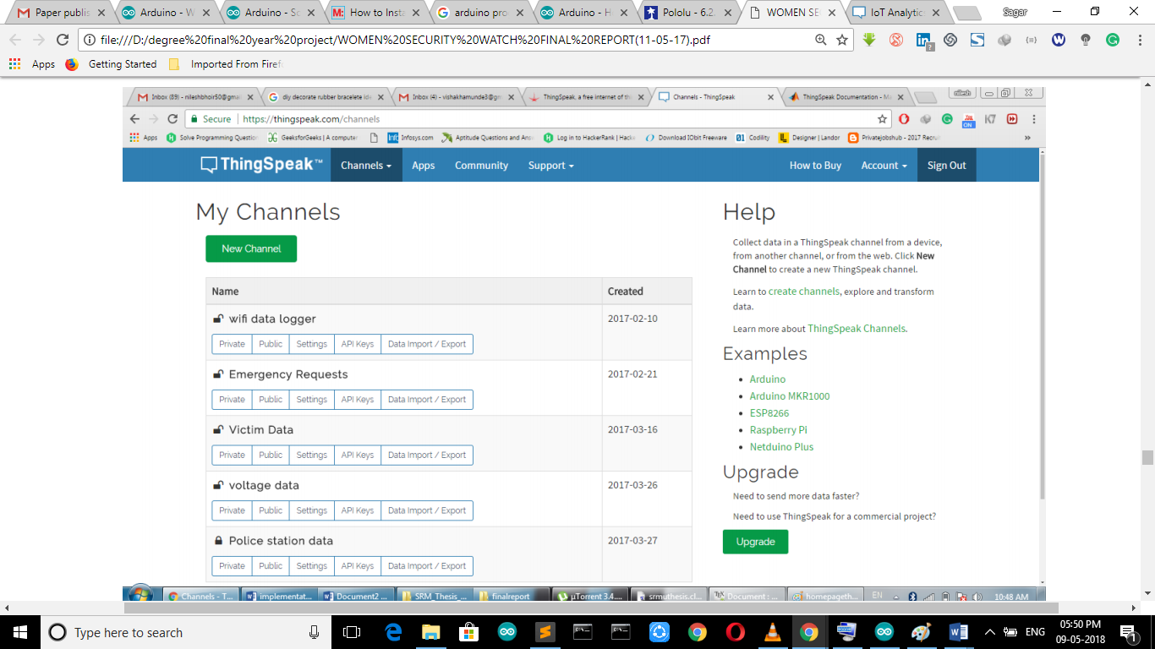

**Figure 10.5: Screenshot of Thingspeaks Channel List**

**10.1.3REACT**

Reacts allow us to trigger a ThingHTTP request or send a tweet using ThingTweet when your ThingSpeak Channel meets a certain condition. We can post a Twitter status when emergency action is to take place. We can create lots of different reactions to sensor data with the React, a ThingSpeak App. We have implemented REACT actions for Sending SMS to emergency contacts and posting a twitter update in case of new request arises. Create a React

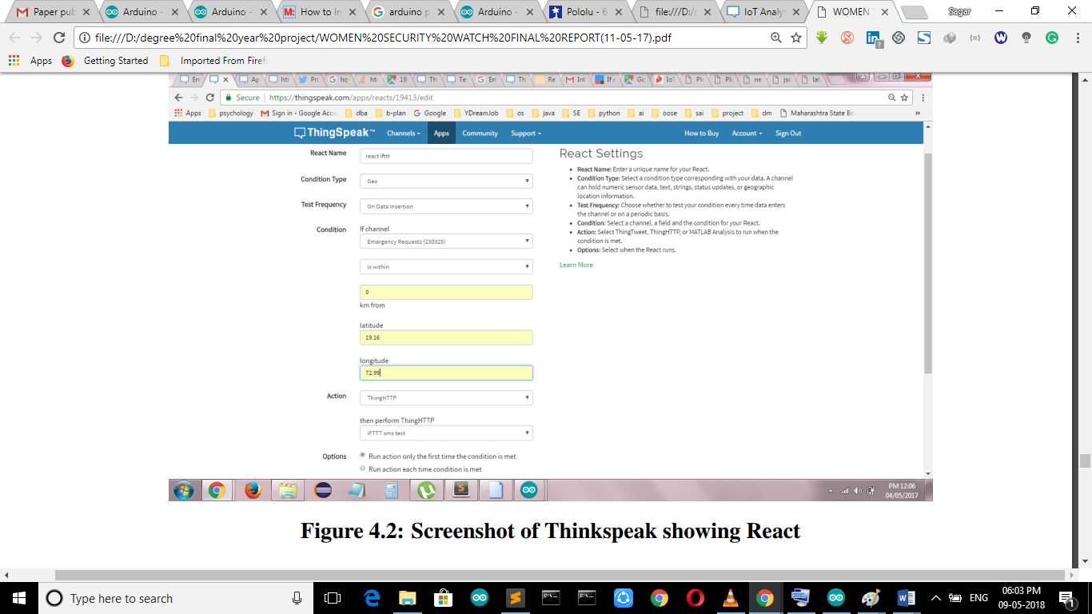

**Figure 10.6: Screenshot of Thinkspeak showing React**

**10.1.4ThingHTTP**

Thinghttp is executed after react condition is met. ThingHTTP enables communication among devices, websites, and web services without having to implement the protocol on the device level. We can specify actions in ThingHTTP, which you trigger using other ThingSpeak apps such as TweetControl, TimeControl, and React.

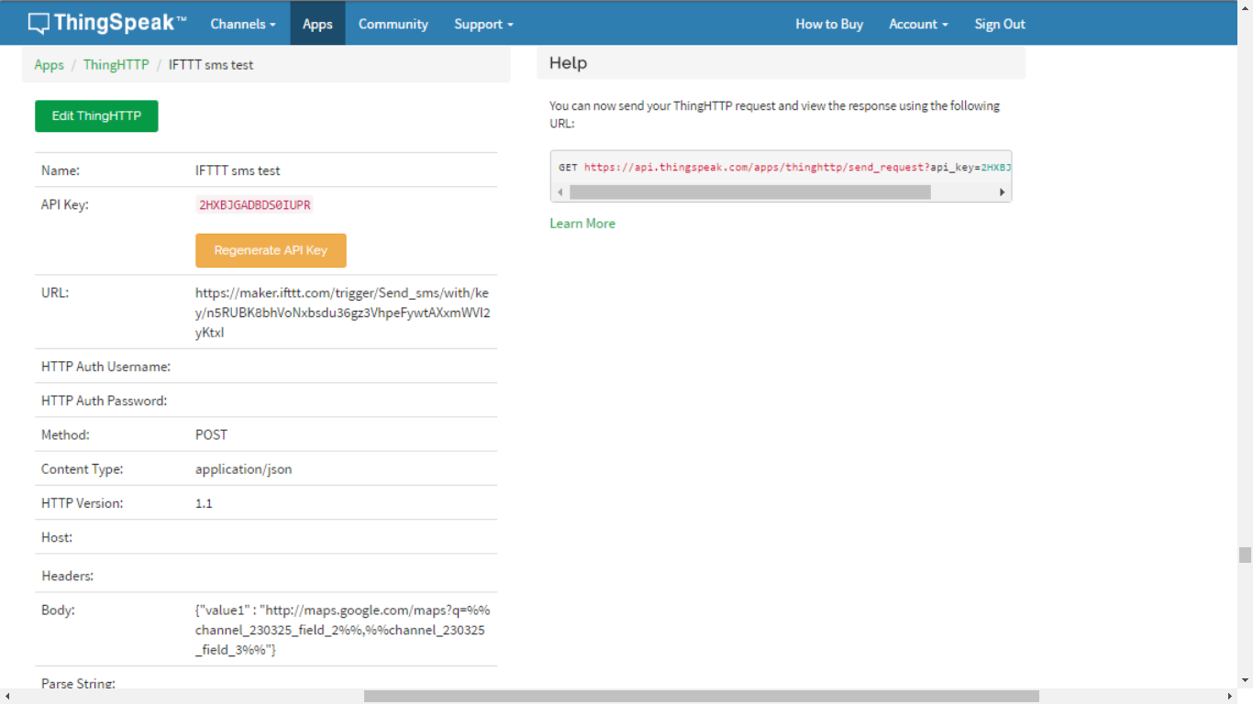

**Figure 10.7: Screenshot of ThingHTTP**

**10.1.5 IFTT**

The information about the patient is sent to the ActOn module using IFTTT Maker applet. The steps involved are:

Step 1: Connect through your IF app (aka IFTTT) to the new Maker channel, you will receive an unique key "YOURKEY" followed by a URL to fire the "test" event

Step 2: Paste the maker key inside our Thinghttp app of thinspeak with body as triggered value. SMS is received at the destination.

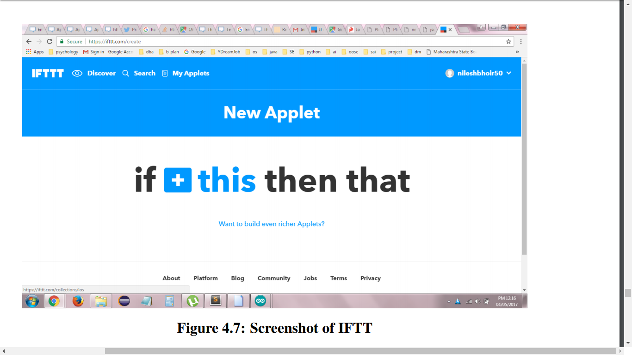

**Figure 10.8: Screenshot of IFTT**

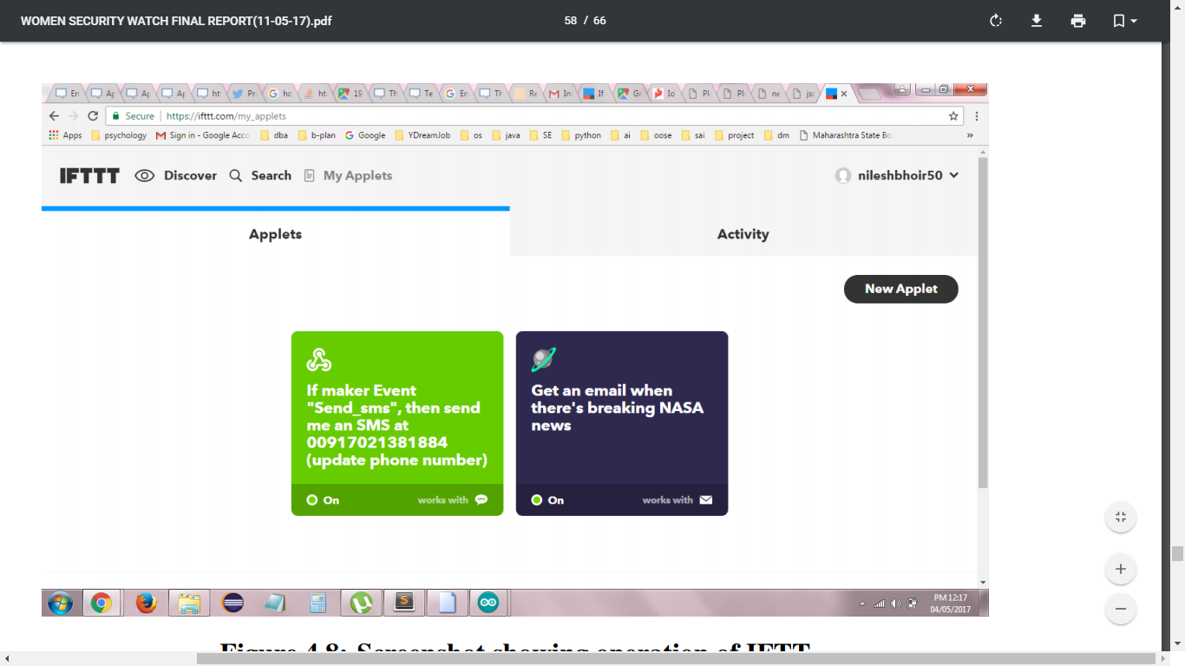

**Figure 10.9: Screenshot showing operation of IFTT**

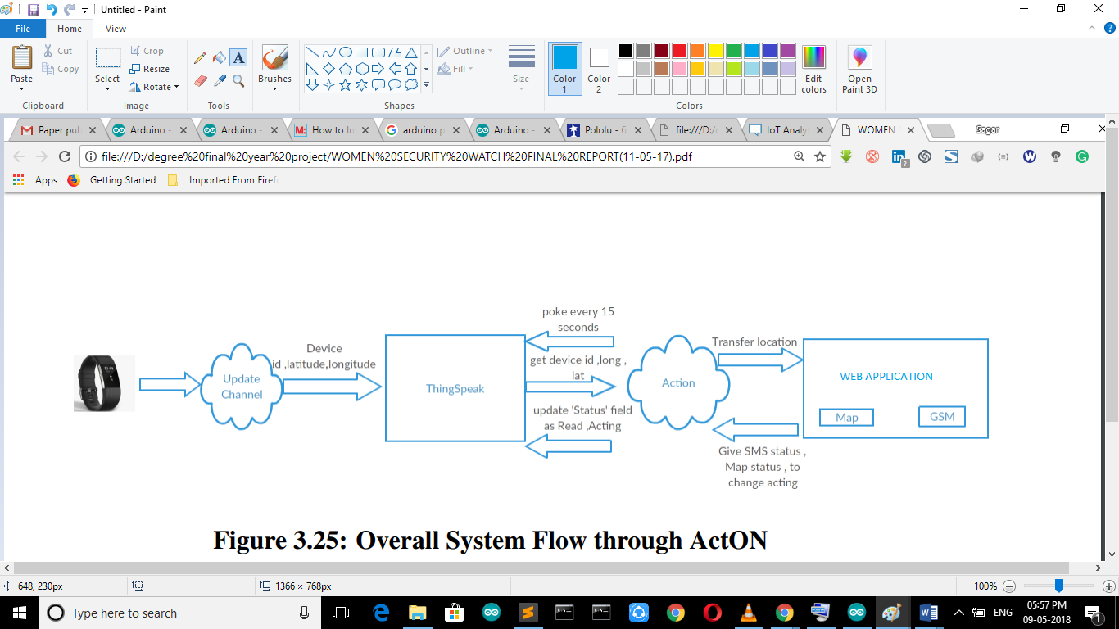

**Figure 10.10: Overall System Flow**

**CHAPTER 11**

**CONCLUSION AND FURTURE SCOPE**

**CONCLUSION**

Cardiovascular sickness is one of the significant reasons for inauspicious passing in world, pulse readings are by a wide margin the main practical indicative apparatus that could advance early recognition of cardiovascular events. By utilizing this we can gauge ones heart rate through fingertip. This paper centre’s around the heart rate observing and ready which can screen the heart beat rate state of patient. The framework decides the heart beat rate every moment and afterward sends short message benefit (SMS) through ThingTweet. It is convenient and financially savvy.

**FUTURE SCOPE**

According to the availability of sensors or development in biomedical trend more parameter can be sensed and monitored which will drastically improve the efficiency of the wireless monitoring system in biomedical field. A graphical LCD can be used to display a graph of rate of change of health parameters over time. The whole health monitoring system which we have framed can be integrated into a microchip which will help the patients to easily carry this device with them wherever they go.

* EEG, ECG and other wellbeing parameters can likewise be checked.
* Continuous checking and future analysis can be performed by means of a similar framework (TELEMEDICINE)
* In excess of a solitary patient at better places can be observed utilizing single framework
* It is likely that specialists and medical attendants would need to be portable. When they visit a patient they could have a tablet PC with all the present outlines and information for that specific patient prepared. The engineering for supporting this could be composed in various ways, however the principle parts that have to be acknowledged would be

1.An foundation for the checking gadgets to drive their information into, for instance a server with database.

2. A framework for the cell phones to get the information.

3.It could likewise be acknowledged in such way that the checking gadget stores every one of the information and applications requiring information associated straightforwardly to the observing gadget.

Annexure A References and hard copies of papers

Annexure B Project Planner

Annexure C Reviewers Comments of Paper Submitted

Annexure D Plagiarism Report

Annexure H Information of Project Group Members

Annexure I Bibliography